October 9, 2024

New Delhi, India



USER interface GUIDE

*EmpowerU Cash+ Programme*

USER Interface GUIDE

*EmpowerU Cash+ Programme*

**Revision History**

|  |  |  |  |
| --- | --- | --- | --- |
| Name | Date | Reasons of Changes | Version |
| Itm | 09th October 2024 | The first draft of the User Interface Empower U Cash+ Programme | V1 |
| Itm | 15th October 2024 | The Second draft of the User Interface Empower U Cash+ Programme | V2 |

Table of Contents

1.0 INTRODUCTION 5

2.0 HOME 6

3.0 ABOUT US 7

4.0 INFORMATION KIOSK 8

5.0 CONTACT 9

6.0 LOGIN 10

6.1 AT A GLANCE 11

**6.1.1 KEY FACTS** 11

**6.1.2 REGISTRATION** 12

**6.1.3 CASH TRANSFER** 16

**6.1.4 GRIEVANCE/ COMPLAINT** 19

**6.1.5 POST DISTRIBUTION MONITORING** 23

6.2 REGISTRATION 27

**6.2.1 EXPORT** 28

**6.2.2 IMPORT** 34

**6.2.3 ADD** 35

**6.2.4 APPROVE/REJECT REGISTRATION** 41

**6.2.6 GRIEVANCE** 46

6.3 CASH TRANSFER 49

**5.4.1 ELIGIBLE** 51

**5.4.2 VERIFICATION** 54

**5.4.4 APPROVAL** 57

**5.4.5 PAYMENT** 60

6.4 POST DISTRIBUTION EXPENDITURE 64

**6.2.1 EXPORT** 65

**6.2.2 IMPORT** 68

**6.2.3 ADD** 69

5.5 ADMIN 73

**5.5.1 SUMMARY** 74

**5.5.2 AREA** 76

**5.5.5 CLASSIFICATION** 82

**5.5.3 PROGRAM CYCLE** 85

**5.5. USER** 89

**5.5.7 REPORTS** 92

**5.5.7 RESOURCES** 98

**5.5.8 KEYFACTS** 101

**5.5.8 IMPORT LOG** 104

# **1.0 INTRODUCTION**

The EmpowerU Cash+ Programme Management Information System (MIS) is developed as a web-based MIS system that includes data collection, transaction management, and report generation modules to automate beneficiary management in the **Empower U Cash+** portal. The platform has tools developed for various processes including registration, cash transfers, and post-distribution expenditure. The platform will comprise various independent modules. Below is the list of all the modules:

1. Home
2. About Us
3. Information Kiosk
4. Contact
5. Login

5.1 At a Glance

5.2 Registration

5.3 Cash Transfer

5.4 Post Distribution Expenditure

5.5 Admin

5.5.1 Summary

5.5.2 Area

5.5.3 Classification

5.5.4 Program cycle

5.5.5 User

5.5.6 Report

5.5.7 Resource

5.5.8 Keyfacts

5.5.9 Import Logs

You will land on the home page of the application. Let us understand the features of the home page in the next chapter.

# **2.0 HOME**

The **EmpowerU** platform is a web-based system which can be accessed through a web browser (recommended browser - Google Chrome latest version). Enter the URL <https://empoweru.itechmission.org/home/> in the web browser. The first page you will get to view is the home page. The home page is the landing page of the **Empower U Cash+** portal and has the following options available to navigate through all the modules of the portal -**Home**, **About**, **Information Kiosk, Contact,** and **Login**.

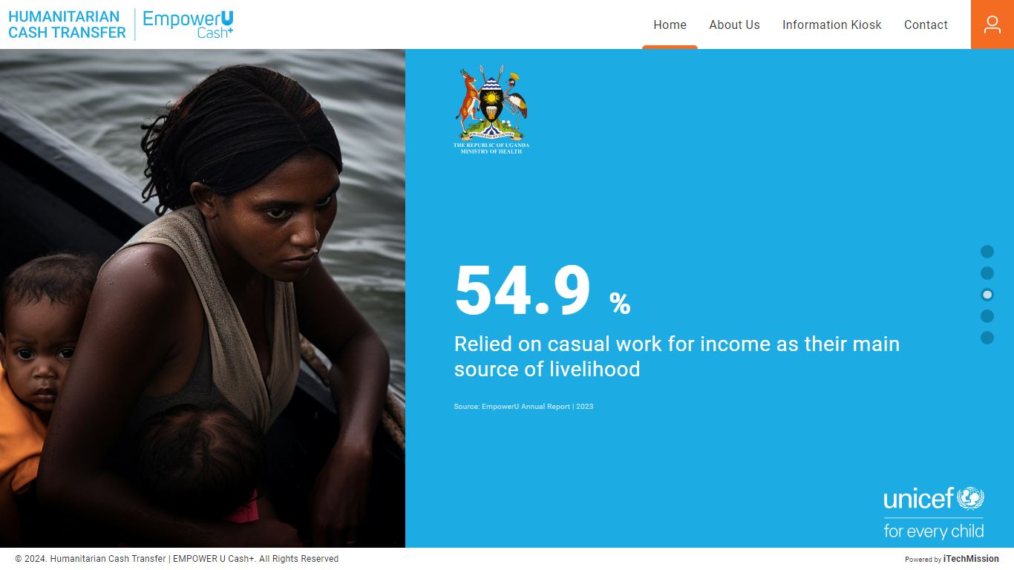This module presents the dynamic key facts which keep on changing in fixed intervals of time (see below figure)

# **3.0 ABOUT US**

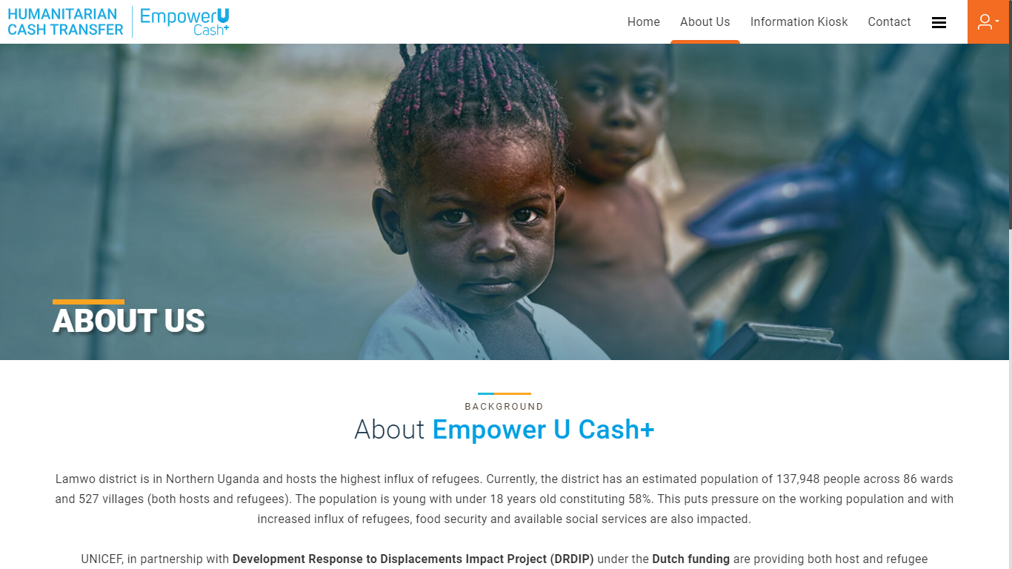Click on the **About Us** option from the home page to navigate to the module. This module presents detailed information about the **Empower U Cash+** programme and its objectives. (see figure below)

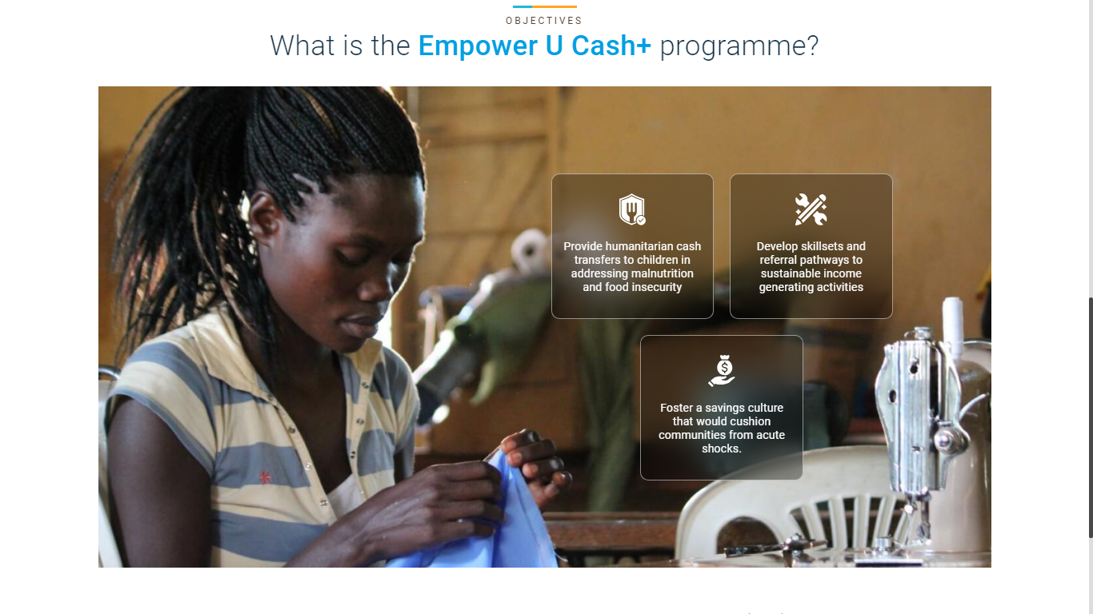

# **4.0** **INFORMATION KIOSK**

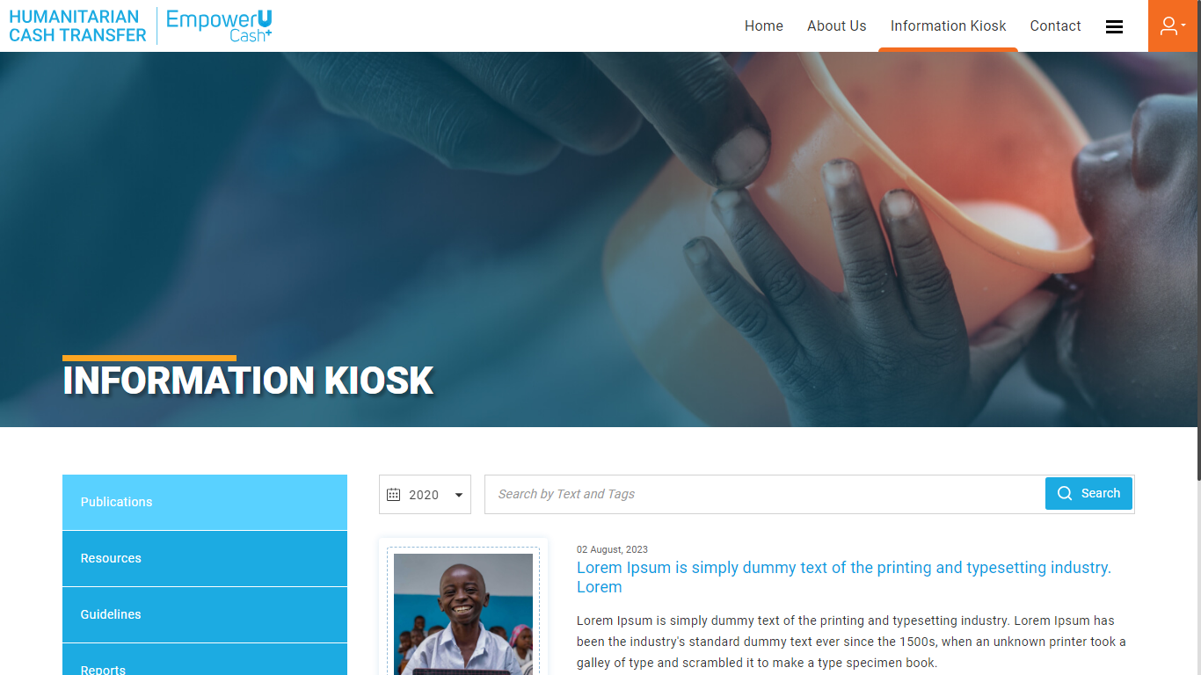Click on the **Information Kiosk** option from the home page to navigate to the module. This module presents the reference documents relevant to the **Empower U Cash+** portal. You will be able to view the **Resources** grouped by category – **Publications, Resources, Guidelines, and Reports**. You can either view **All** the resources or filter them by category. You can also **Search** resources by entering text in the search bar available at the top right corner. Additionally, you can **Select** the year from the drop-down to view the records based on the desired year. (see below figure)

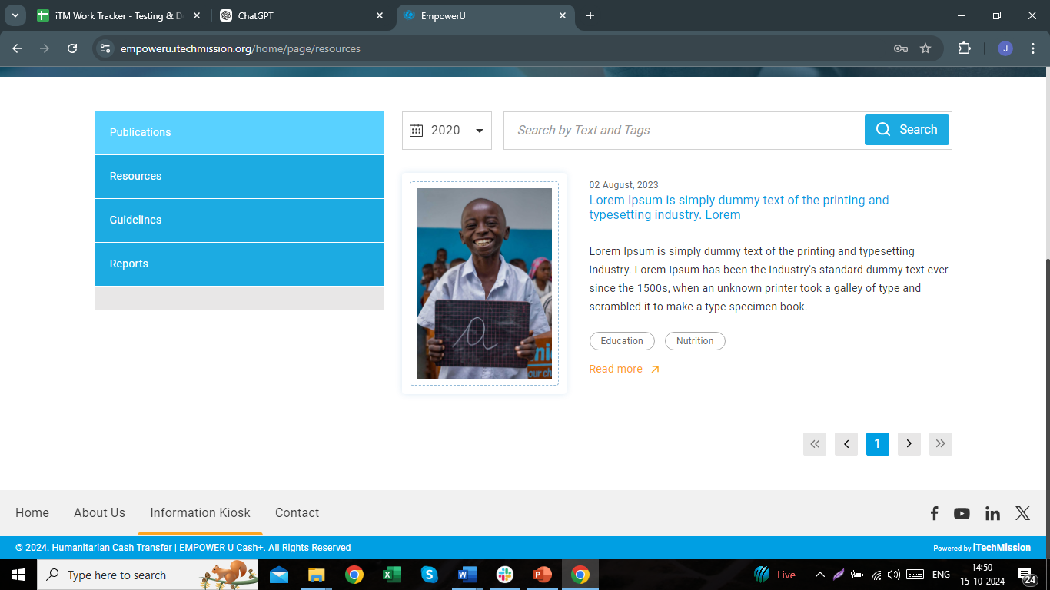Click on the **Read More** button available with each resource to read the full description of that resource. (see below figure).

# **5.0 CONTACT**

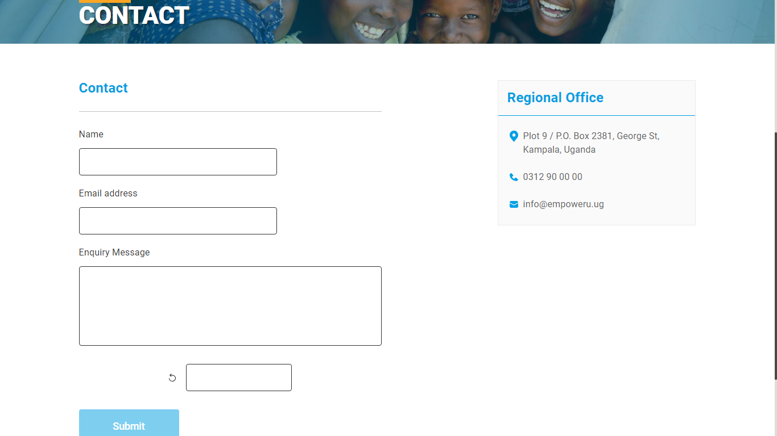Click on the **Contact** menuoption from the home page to navigate to the module. This module provides the Address and Contact details of the KCCA Regional Office. To send an inquiry message to KCCA officials, enter your **Name**, **Email** **Address**, and **Enquiry Message**, then click on Submit (see below figure)

# **6.0 LOGIN**

Click on the **Login** icon from the home page to enter the credentials and get access to the other modules of the portal based on your roles and permissions assigned by the administrator.

*“This user guide is developed for the Administrator Role. The admin is able to access all the modules of the EmpowerU MIS Portal whereas the modules and permissions will vary based on the other user roles.”*

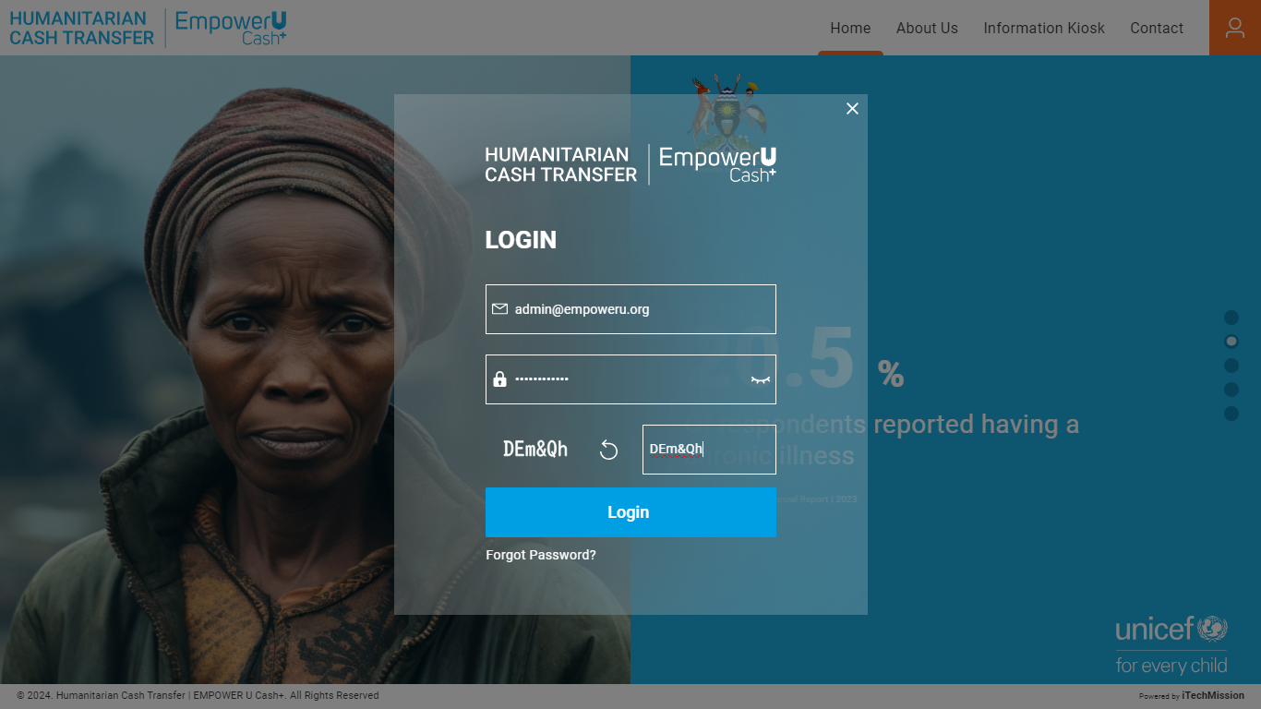Enter a valid Email ID & Password and click on Login (see below figure)

Click on the **Forgot Password** option that will allow you to enter your user name/email id where you can receive a reset password link.

## **6.1 AT A GLANCE**

This is the first module after the successful login into the portal. This module can be accessed by all the users and is program cycle and time-period-driven. This module presents summarized data on **Cash Transfers, Registrations, Post Distribution Monitoring, and Grievances / Complaints** of the households using various visualizations. Each data is presented in a widget with the option to view the detailed information of the selected data.

### **6.1.1 KEY FACTS**

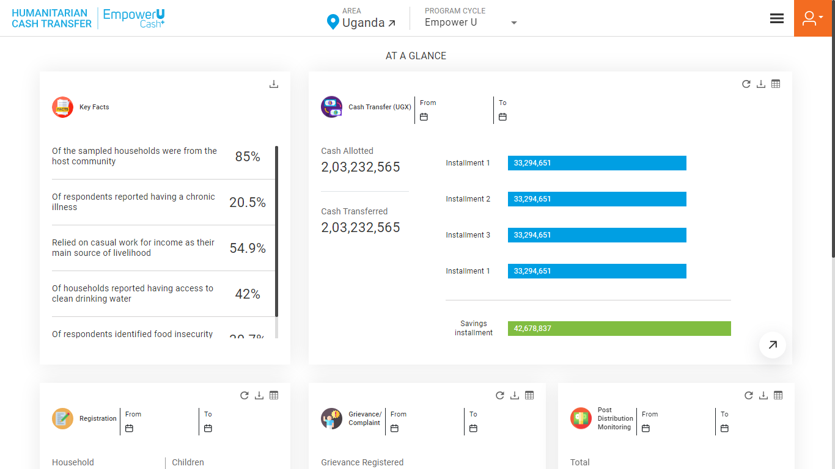The **Key facts** are shown on the left side of the page. These emphasize the necessity of the humanitarian cash transfer program by showcasing the socioeconomic challenges faced by the community. Click on the **Download** button available on the top right corner of the widget to download the key facts. (see below figure)

### **6.1.2 REGISTRATION**

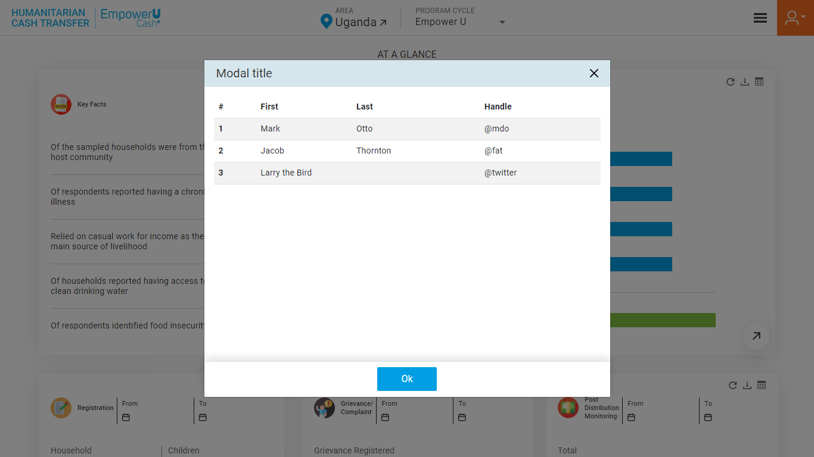Next is the **Registration** widget which presents the summarized data on registered households. The widget provides information about the total **Households, Household Heads, Children,** and **Children with Disability** of the selected program cycle. The legend for the data is available at the bottom of the visualization. Click on the **Table** button available at the top right corner to view the **Registration** data in a tabular grid (see below figure).

Click on the **Download** button to download the **Registration** data in JPEG format. Click on the **Arrow** button available at the bottom to view the detailed information on **Registration** for each household (see below figure). 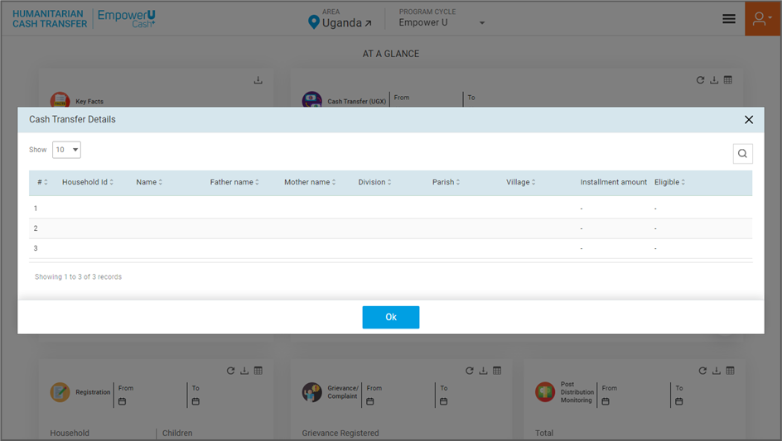

Click on the **Search** option to find the **Registration** data based on the typed text. (see below figure). 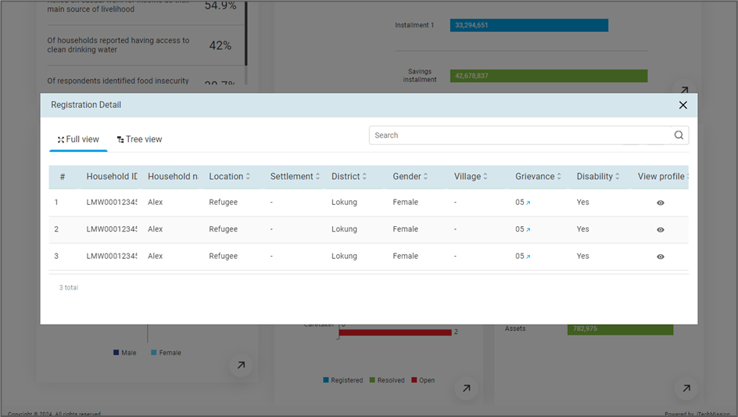

The detailed **Registration** data is presented in two views – **Full View** and **Tree View**. By default, the full view will be selected and the **Registration** details of all the households is presented using heat map visualization. The legends for the paid and rejected installments is available at the bottom. Click on the **Tree View** option to view the **Registration** data of all the households by their assigned peer mentors (see below figure ) 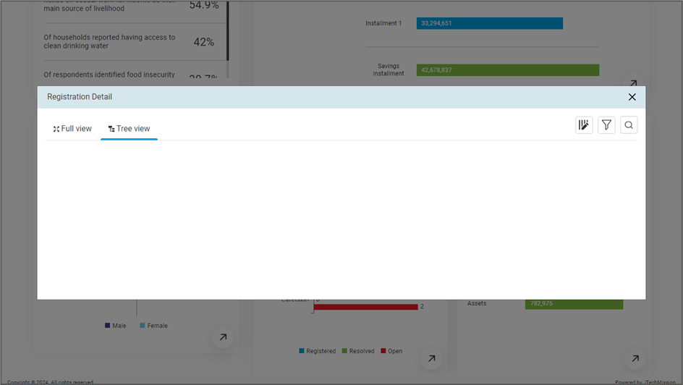

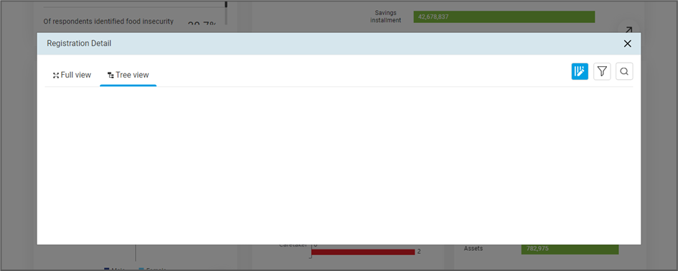You can click on the name of **Partners** available on the left side to view the lead mentors assigned to the selected partner and households’ **Registration** details assigned to the program coordinator.

Click on the **Manage Columns** option available to show/hide the columns of the table (see below figure

Click on the **Filter** option to filter the **Registration** data based on the selected parameter (see below figure) 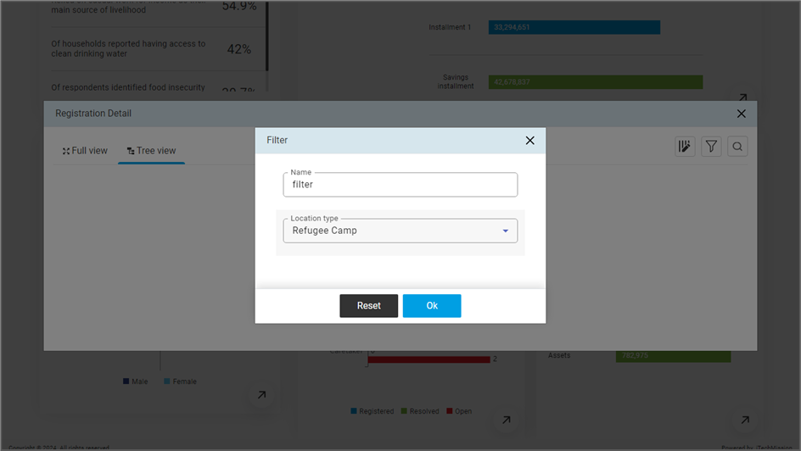

### **6.1.3 CASH TRANSFER**

Next is the **Cash Transfer** widget which presents the summarized data on cash transferred to the households. The widget provides information about the total **Cash Allotted**, **Cash Transferred**, and **Installments** of the selected program cycle. The legend for the data is available on the right side of the visualization. Click on the **Table** button available at the top right corner to view the **Cash Transfer** data in a tabular grid (see below figure).

Click on the **Download** button to download the **Cash Transfer** data in JPEG format. Click on the **Arrow** button available at the bottom to view the detailed information on **Cash Transfer** for each household (see below figure).

Click on the **search** option to find the **Cash Transfer** data based on the typed text. (see below figure). 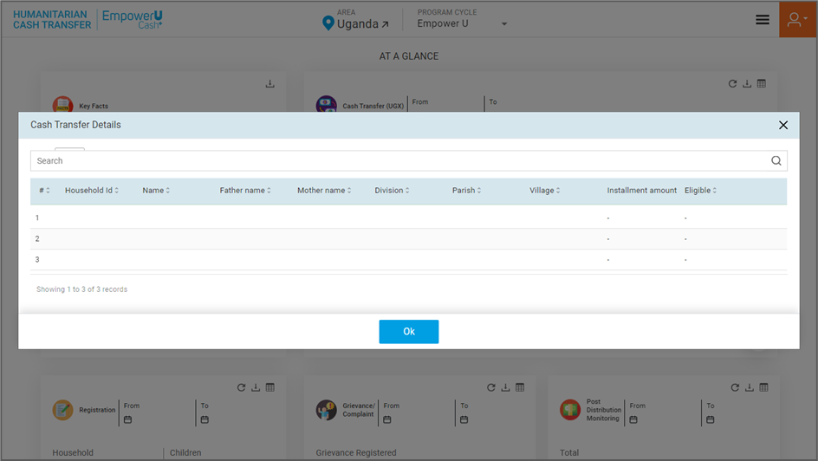

### **6.1.4 GRIEVANCE/ COMPLAINT**

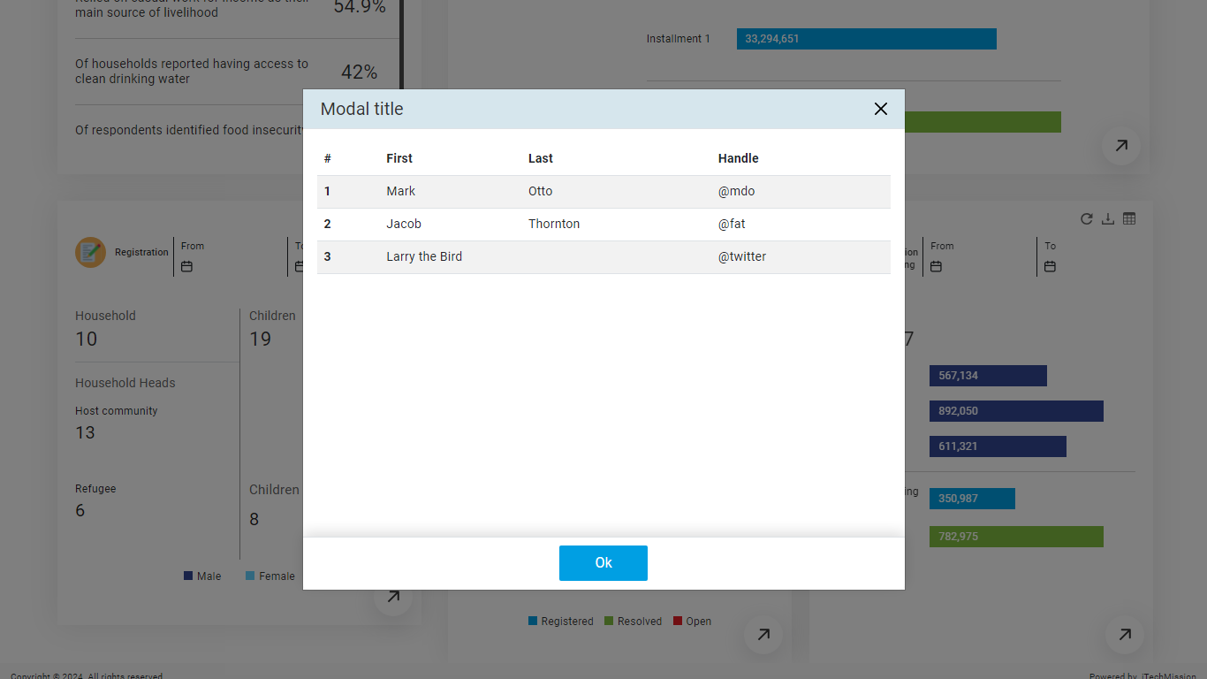Next is the **Grievance** widget which presents the summarized data on registered households. The widget provides information about the total **registered grievances** anda **bar chart** forregistered, open, and resolved grievance types– **Cash Transfer, Mentor Related, and Caretaker** of the selected program cycle. The legend for the data is available at the bottom of the visualization. Click on the **Table** button available at the top right corner to view the **Grievance** data in a tabular grid (see below figure).

Click on the **Download** button to download the **Grievance** data in JPEG format. Click on the **Arrow** button available at the bottom to view the detailed information on **Grievance** for each household (see below figure). 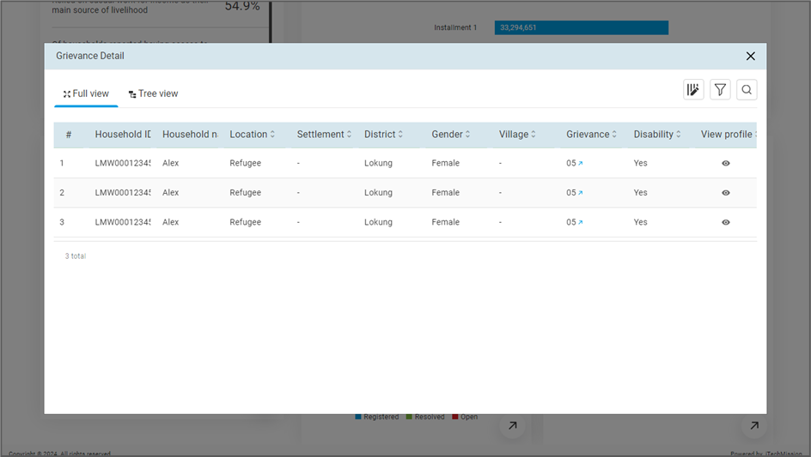

Click on the **Search** option to find the **Grievance** data based on the typed text. (see below figure). 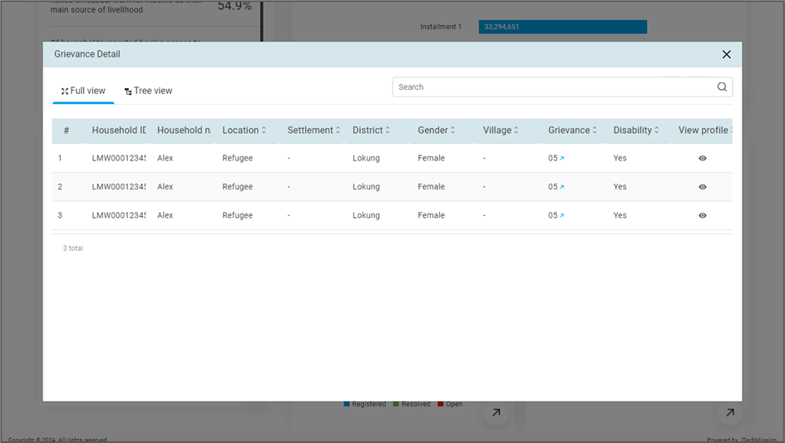

The detailed **Grievance** data is presented in two views – **Full View** and **Tree View**. By default, the full view will be selected and the **Grievance** details of all the households are presented using heat map visualization. The legends for the paid and rejected installments are available at the bottom. Click on the **Tree View** option to view the **Grievance** data of all the households by program coordinator. (see below figure) 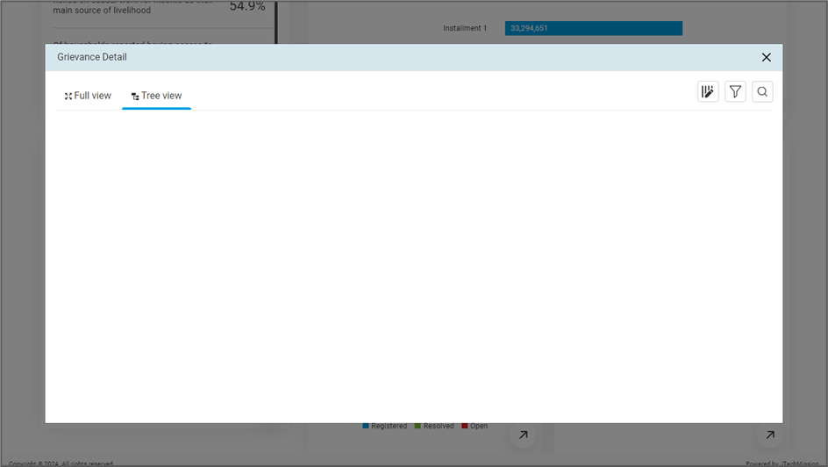

You can click on the name of **Partners** available on the left side to view the lead mentors assigned to the selected partner and households’ **Grievance** details assigned to the program coordinator.

Click on the **Manage Columns** option available to show/hide the columns of the table (see below figure 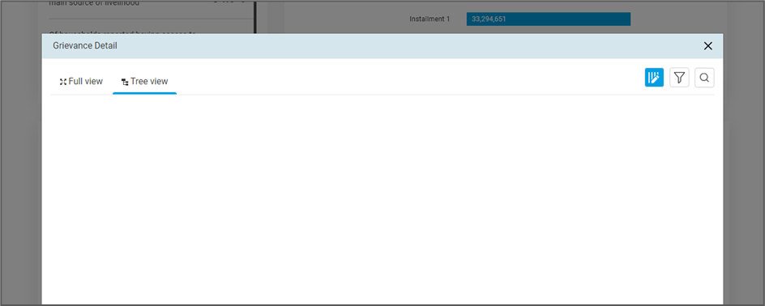

Click on the **Filter** option to filter the **Grievance** data based on the selected parameter (see below figure) 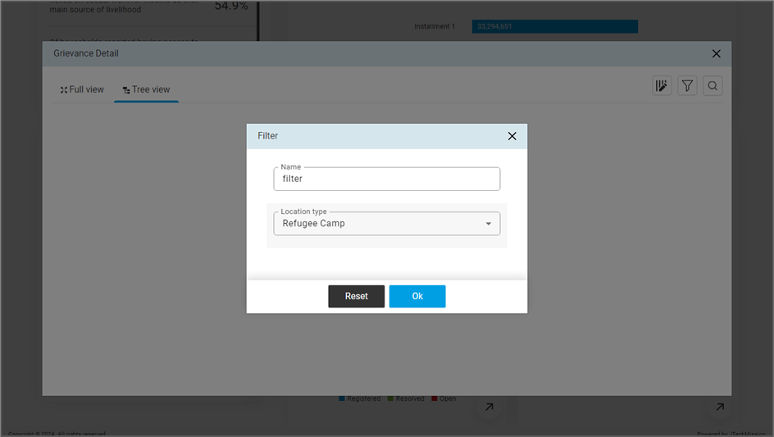

### **6.1.5** **POST DISTRIBUTION EXPENDITURE**

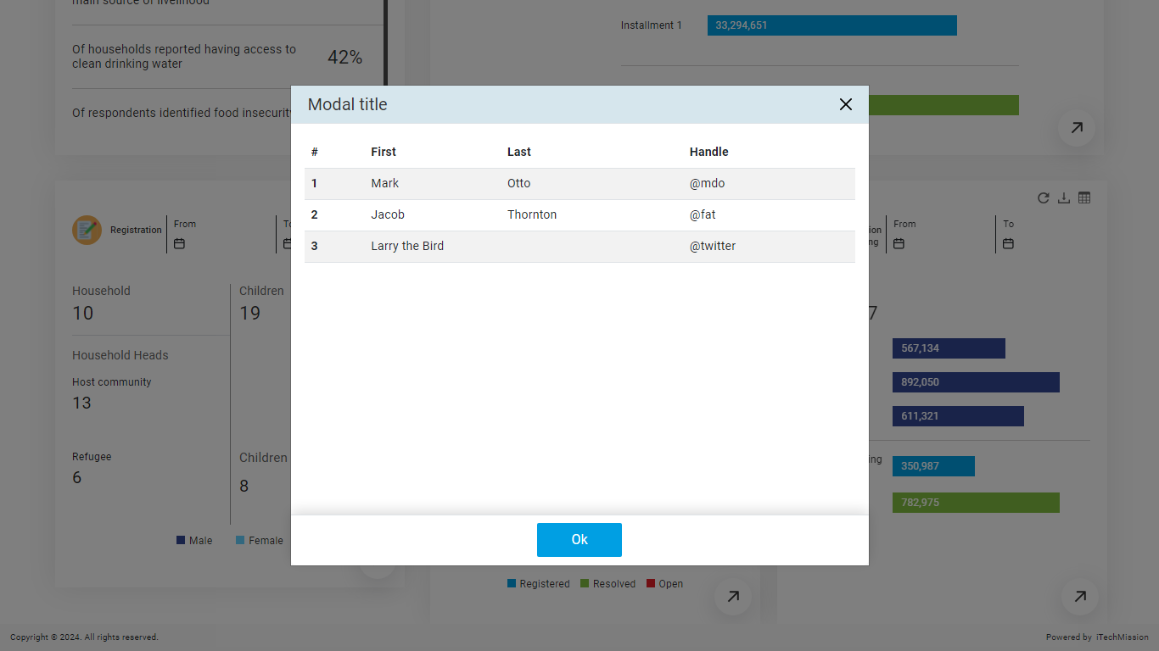Next is the **Post Distribution Expenditure** widget which presents the summarized data on registered households. The widget provides information about the total distribution in Food, Education and heath and Income generating  
activities (IGA) and Assetsof the selected program cycle. Click on the **Table** button available at the top right corner to view the **Post Distribution Monitoring** data in a tabular grid (see below figure).

Click on the **Download** button to download the **Post Distribution Expenditure** data in JPEG format. Click on the **Arrow** button available at the bottom to view the detailed information on **Post Distribution Expenditure** for each household (see below figure). 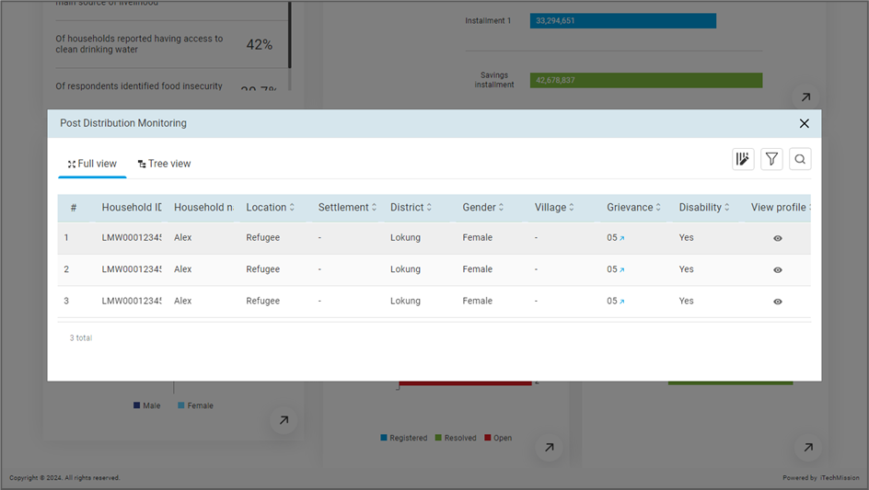

Click on the **Search** option to find the **Post Distribution Expenditure** data based on the typed text. (see below figure). 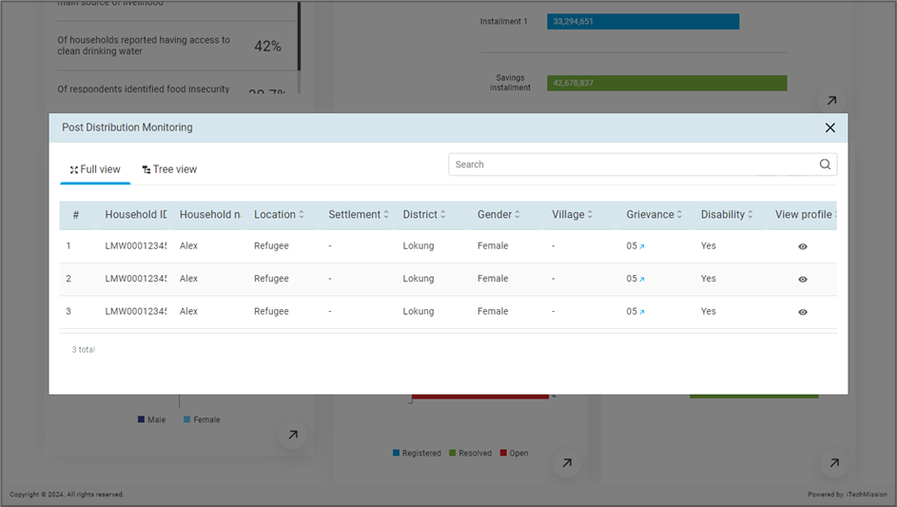

The detailed **Post Distribution Expenditure** data is presented in two views – **Full View** and **Tree View**. By default, the full view will be selected and the **Grievance** details of all the households are presented using heat map visualization. The legends for the paid and rejected installments are available at the bottom. Click on the **Tree View** option to view the **Post Distribution Expenditure** data of all the households by program coordinator. (see below figure) 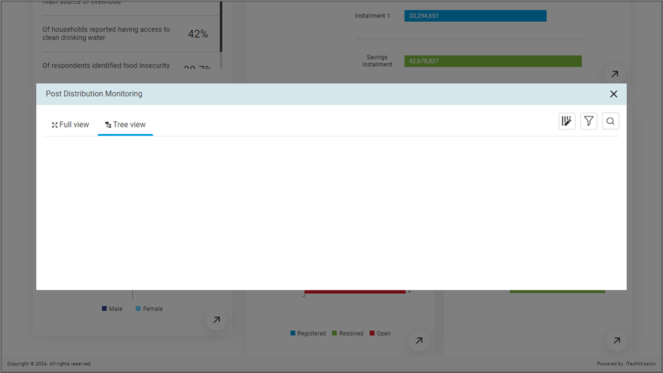

You can click on the name of **Partners** available on the left side to view the lead mentors assigned to the selected partner and households’ **Post Distribution Expenditure** details assigned to the program coordinator.

Click on the **Manage Columns** option available to show/hide the columns of the table (see below figure 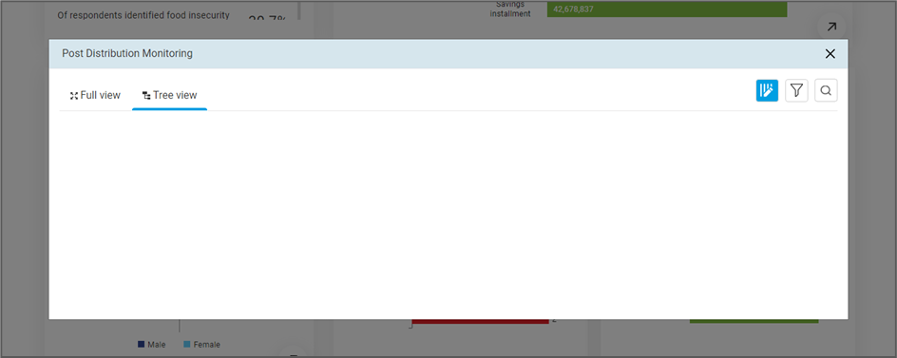

Click on the **Filter** option to filter the **Post Distribution Expenditure** data based on the selected parameter (see below figure) 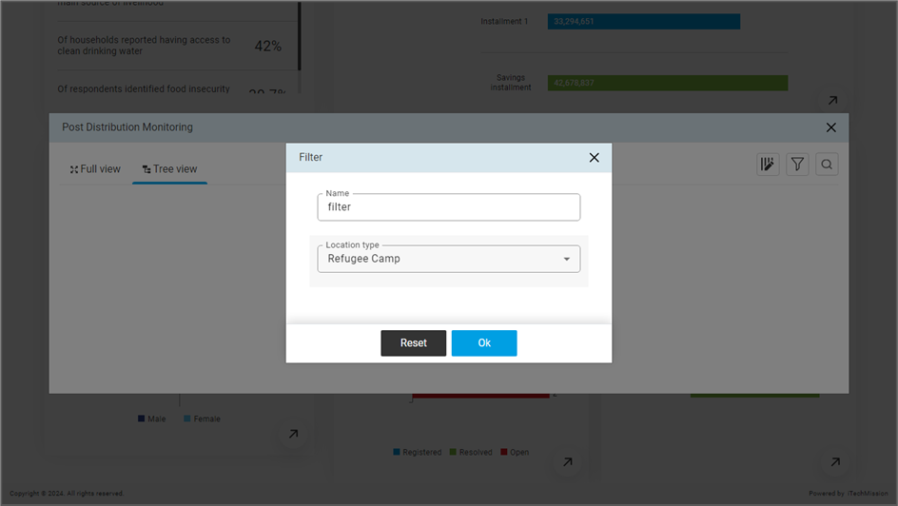

## **6.2 REGISTRATION**

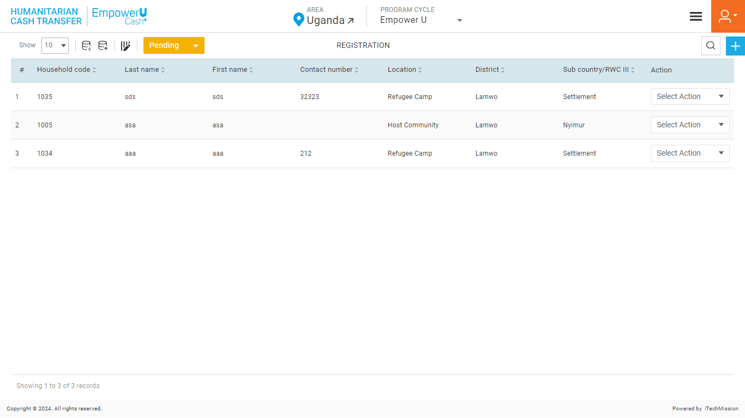Click on the **Registration** option from the burger menu to access this module. This module is program cycle and registration status driven and allows you to manage the registration of households in the **Empower U Cash+**. You have the option to export and import household registration data, add new households, view the list of existing households, approve or reject a pending household, and sort, search, delete, and update the household details (see figure below).

### **6.2.1 EXPORT**

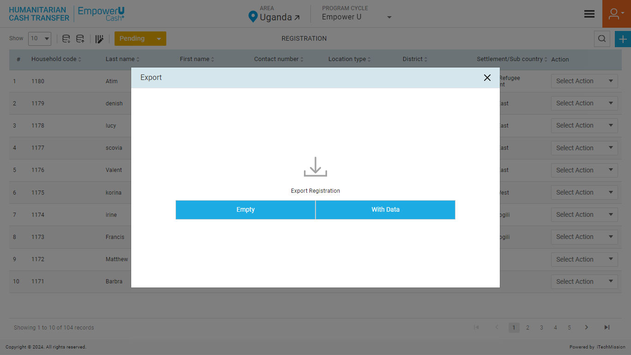Click on the **Export** button to download the empty household Registration template and household data available in the database (See below figure).

Below is the area structure that you will find in the Registration template.

**General Information**

|  |  |
| --- | --- |
| **ProgramCycle** | The cycle in which a household is enrolled |
| **Household ID** | Unique ID for every household |
| **HouseholdType** | HouseholdType of the household *(select from the Host Community and Refugee Camp)* |
| **CountryOfOrigin** | In the case of Location Refugee camp, select the origin. |

**Respondent details :**

|  |  |
| --- | --- |
| **RespondentID** | NIN no.of the head of the household |
| **RespondentLastName** | Last name of the head of the household |
| **RespondentFirstName** | First name of the head of the household |
| **RespondentOtherName** | Other name of the head of the household |
| **RespondentTelephoneNumber** | The telephone number of the head of the household |

**Area details :**

|  |  |  |
| --- | --- | --- |
| **Area levels** | **Host Community** | **Refugee Camps** |
| **Level1** | Country | Country |
| **Level2** | District | District |
| **Level3** | Sub- Country | Settlement |
| **Level4** | Watershed | RWIII |
| **Level5** | Parish | RWII |
| **Level6** | Village | RWI |
| **Level7** | Sub-project | Sub-project |

**Household Member Details:**

|  |  |
| --- | --- |
| **Member.NameOfHouseholdMember** | Name of the household Member |
| **Member.Gender** | Gender of the household member |
| **Member.DateOfBirth** | Date of birth of the household member |
| **Member.Age** | Age of the household member |
| **Member.BirthCertificateStatus** | Does household member has a birth certificate – YES/NO |
| **Member.BirthRegistrationStatus** | Has household member's birth been registered with health facility? – YES/NO |
| **Member.RelationshipWithHouseholdHead** | What is the relationship with household head |
| **Member.MotherLivingStatus** | Is household member's mother alive |
| **Member.FatherLivingStatus** | Is household member's father alive |
| **Member.SchoolEnrolmentStatus** | Is household member enrolled in school |
| **Member.ClassGrade** | Select the grade household member is in |
| **Member.ReasonOfNonEnrolment** | Why is household member not enrolled in school? |
| **Member.OtherReason** | Specify other reason for non-enrolment |
| **Member.PregnancyStatus** | Is household member pregnant |
| **Member.ExpectedDueDate** | What is expected due date |
| **Member.ChronicIllnessStatus** | Is household member chronically ill |
| **Member.ChronicIllnessType** | Name the chronic illness |
| **Member.ChronicIllnessTypeOther** | Name other chronic illness |
| **Member.TreatmentForIllnessStatus** | Specify other chronical illness |
| **Member.ReasonOfNoTreatment** | Is household member not seeking treatment for illness |
| **Member.ReasonOfNoTreatmentOther** | What is the reason for not seeking health treatment |
| **Member.ChronicIllnessNoTreatmentReasonOther** | Specify other reasons for not seeking health treatment |
| **Member.DisabilityStatus** | Does household member has any form of disability |
| **Member.DisabilityType** | Name the disability |

**Household Condition Details**

|  |  |
| --- | --- |
| **MainSourceOfLivelihood** | What have been the households’ main sources of livelihoods in the past 6 months? |
| **MainSourceOfLivelihoodOther** | Specify other main source |
| **SupportByExternalSources** | Has your household received any support or participate in any programmers or services provided by external sources ( non-family members) during the last 12 months? |
| **ExternalSupportType** | Who was this support from? |
| **HouseholdFloorMajorMaterial** | What is the major material of the floor of the household? |
| **HouseholdToiletType** | What type of toilet is mainly used in your household? |
| **MealCountInLastWeek** | How many meals did the children between the age of 2-5 eat in the last seven days (last week)? |
| **NoFoodInPast30Days** | In the past 30 days, was there ever a day where there was no food to eat of any kind in your house because of lack of resources to get food? |
| **NoFoodInPast30DaysFrequency** | How Often did this happen in the past 30days? |

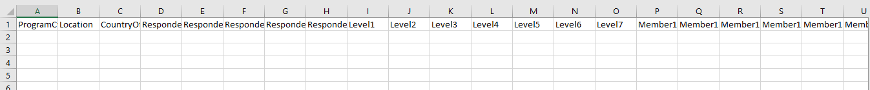Click on the **Empty** button to download an empty registration template use this template to create the registration data of the potential household. (see below figure).

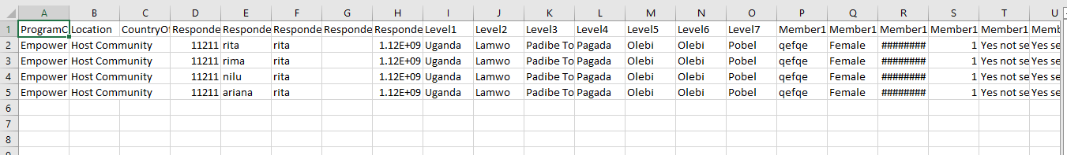Click on the **With Data** button to download the registration data available in the database (see below figure).

*The list is exported in the CSV (Comma Separated Value) file format.*

### **6.2.2 IMPORT**

Click on the **Import** button to browse the file and upload the household list into the database. (See below figure).

To upload the household list into the database, enter the household details in the epmty template above and then click on the **Browse File** button to select the template. Then, click on the **Upload** button to start the import process.

*The records which contain blank entries, entries with special characters, and duplicate entries will not be imported into the database.*

The Last Upload summary provides the count of total and imported records. A log will be generated for the failed records which were duplicated, failed, successfully inserted, and updated into the database out of the total records.

### **6.2.3 ADD**

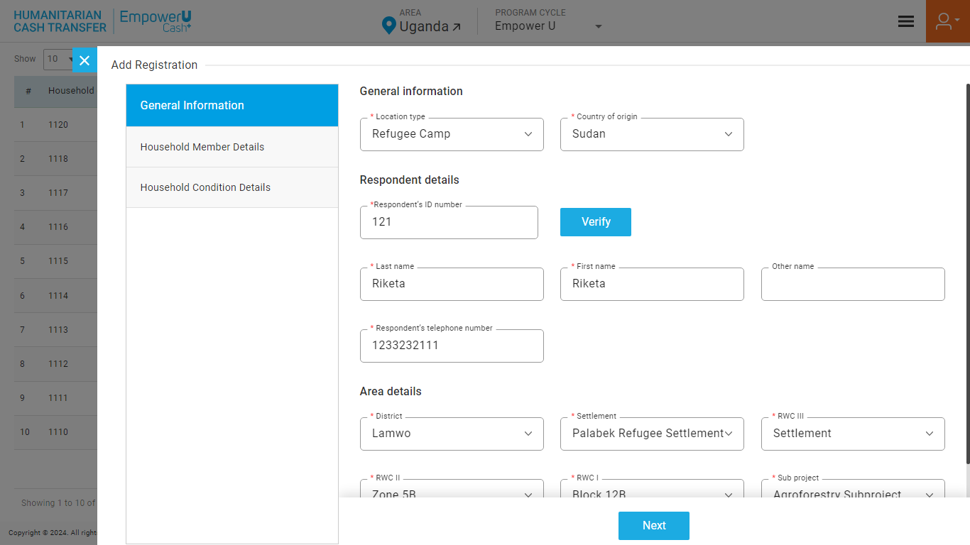Click on the **Plus** button available on the right side of the page to **Add** a new **Household** (see figure below)

Enter the following details to add a new Registration.

**General Information**

|  |  |  |  |  |
| --- | --- | --- | --- | --- |
| **Field** | **Type** | **Import Type** | **Mandatory** | **Associated Classification** |
| **Location type** | List | Single Choice | Yes | Location |
| **Country of origin** | Text |  | No | Country |

**Area Details**

|  |  |  |  |  |
| --- | --- | --- | --- | --- |
| **District** | List | Single Choice | Yes | District |
| **Settlement** | List | Single Choice | Yes | Settlement |
| **Sub County/RWC III** | List | Single Choice | Yes | Sub-county |
| **Parish/RWC II** | List | Single Choice | Yes | Parish |
| **RWC I/Village/Zone** | List | Single Choice | Yes | Village |

**Respondent Details**

|  |  |  |  |  |  |  |  |
| --- | --- | --- | --- | --- | --- | --- | --- |
| **First Name of respondent** | Text | |  | Yes | |  | |
| **Last Name of respondent** | | Text |  | | Yes | |  |
| **Other Name of respondent** | | Text |  | | Yes | |  |
| **Respondent’s telephone number** | Numeric | |  | Yes | |  | |
| **Respondent’s ID number** | Text | |  | Yes | |  | |

**Household Member Details**

|  |  |  |  |  |
| --- | --- | --- | --- | --- |
| **Name** | Text |  | Yes |  |
| **Gender** | List | Single Choice | Yes | Gender |
| **Date of birth** | Date |  | No |  |
| **Age** | Number |  | Yes |  |
| **Birth certificate status** | List | Single Choice | Yes | Birth Certificate |
| **Birth registration status** | List | Single Choice | No | Birth Certificate |
| **Relationship with household head** | List | Single Choice | Yes | Relationship |
| **Mother living status** | List | Single Choice | No | Status |
| **Father living status** | List | Single Choice | No | Status |
| **School enrolment status** | List | Single Choice | No | Status |
| **Class enrolled** | List | Single Choice | No | Grade |
| **Reason of non-enrolment** | List | Multi Choice | No | Reason non-enrolment |
| **Other reason** | Text |  | No |  |
| **Pregnancy status** | List | Single Choice | No | Pregnancy Status |
| **Expected due date** | Date |  | No |  |
| **Chronic illness status** | List | Single Choice | Yes | Status |
| **Chronic illness type** | List | Multi Choice | No | Illness |
| **Other illness type** | Text |  | No |  |
| **Treatment for illness status** | List | Single Choice | Yes | Yes/No |
| **Reason of no treatment** | List | Multi Choice | No | Reason non-treatment |
| **Other reason** | Text |  | No |  |
| **Disability status** | List | Single Choice | Yes | Yes/No |
| **Disability type** | List | Multi Choice | No | Disability |

**Household Condition Details**

|  |  |  |  |  |
| --- | --- | --- | --- | --- |
| **Main source of livelihood** | List | Single Choice | Yes | Main Source |
| **Other main source** | Text |  | No | Status |
| **External source support status** | List | Single Choice | Yes | External Source |
| **External support type** | List | Multi Choice | Yes | Floor Material |
| **Major material used in the floor** | List | Single Choice | Yes | Toilet Type |
| **Type of toilet** | List | Single Choice | Yes |  |
| **Meal count in last week (Children 2-5 yrs)** | Numeric |  | Yes | Yes/No |
| **Food availability status (past 30 days)** | List | Single Choice | Yes | Frequency |
| **Frequency of no food available (past 30 days)** | List | Single Choice | Yes | Status |

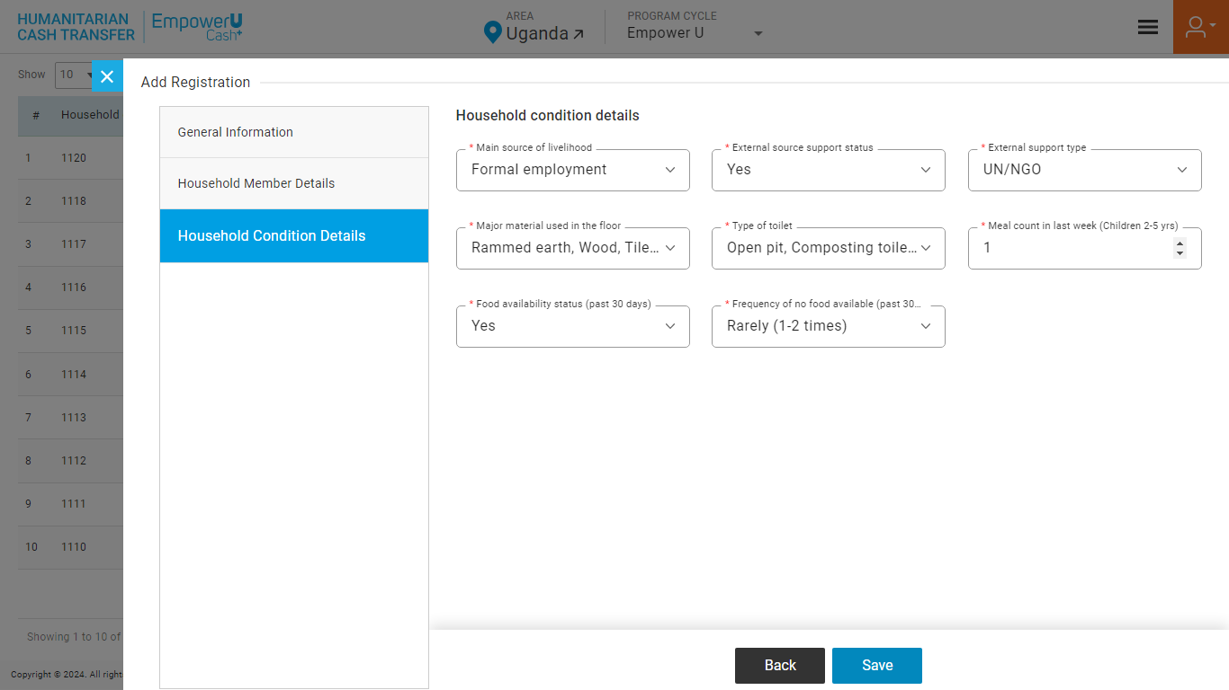Click on the **Save** button to save and confirm. You can now view the households added in the registration list (see below figure).

*The registered household will remain in pending state until approved by the program manager.*

Click the **Search** button and specify the name to view entries.

Selectthe **View** option available in the action dropdown to view the details of the selected element.

Select the **Edit** option available in the action dropdown to edit the details of the selected element. Edit the required detail and click on the update button to save and confirm.

Selectthe **Delete** option available in the action dropdown to delete the selected element. A confirmation popup will appear, click **Yes** to confirm the deletion of the selected element.

Select the **Enable/Disable** option available in the action dropdown to show or hide the specific element. The hidden element will not be shown in the list of selected Area types overall in the application.

### **6.2.4 APPROVE/REJECT REGISTRATION**

Click on the **Registration** category from the notification menu to view the newly registered households that need approval. (see below figure)

Select the **Program cycle** from the header of the application to view all the pending households of the selected program.

You have the option to move a Pending Registration to one of the following states –

* Approved
* Rejected

#### APPROVED HOUSEHOLDS

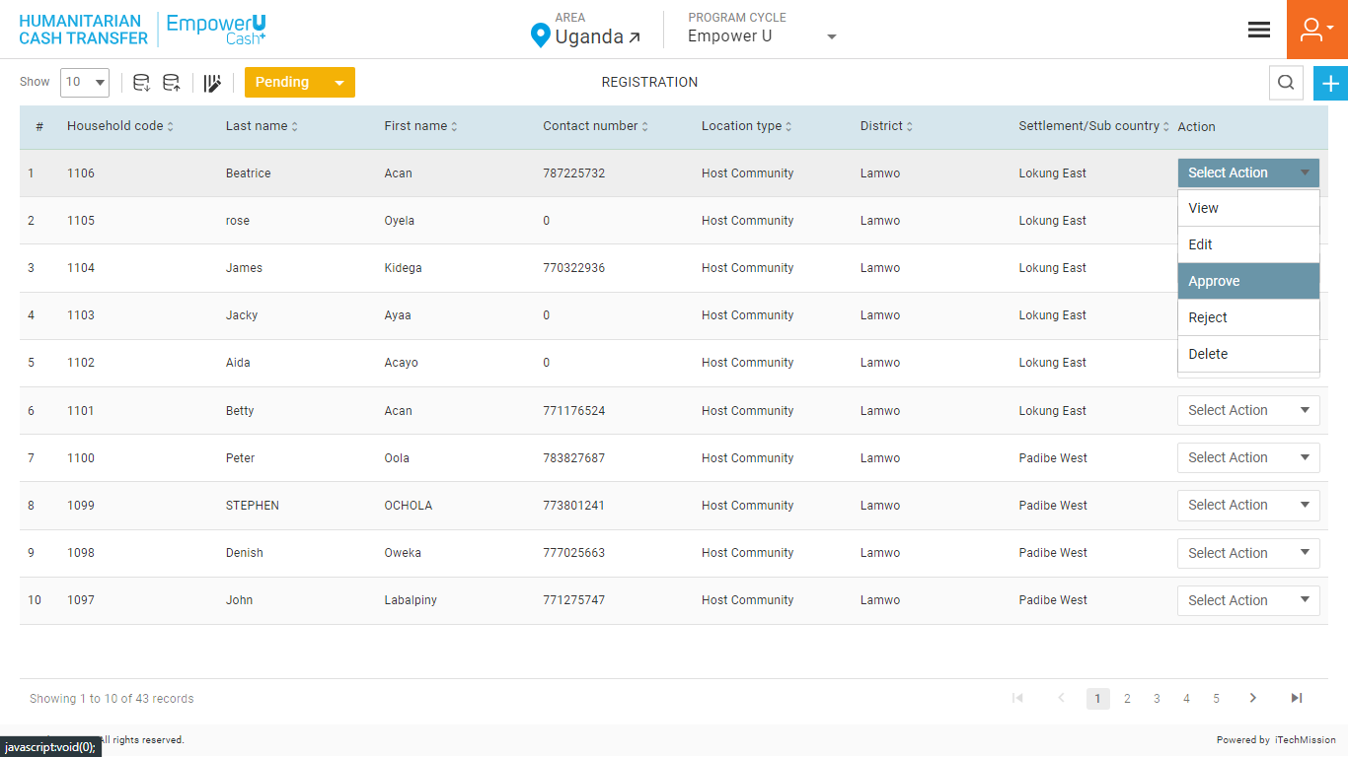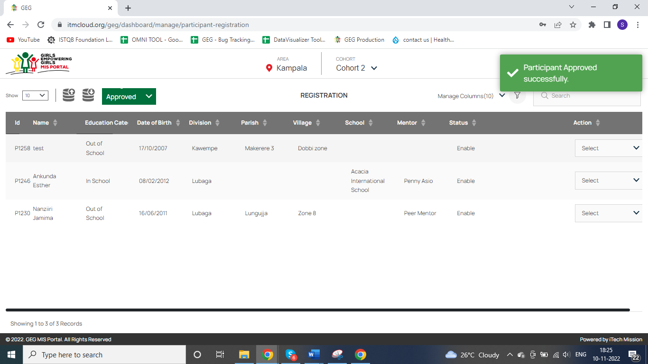In the list of Pending Registrations, click on the **Approve** option from the action column to approve the selected household. The approved household will be moved to the approved registration list. (see below figure).

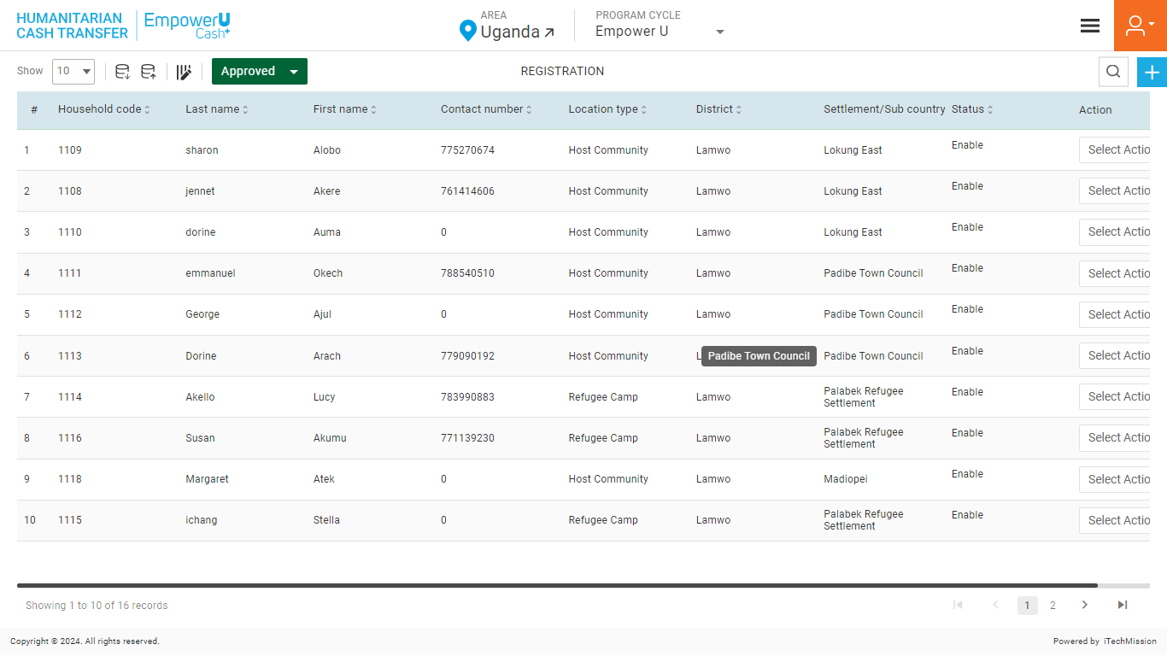Change the status from **Pending** to **Approve** to view the approved household list in the registration Module.(see below figure)

Select the **View Profile** option available in the action dropdown to view the profile of the **Approved** household. A view of Respondent Details, Area Specifics, Area Specifics, Verified Status, Member Details, Cash Transfer, Post Distribution Expenditure, Grievance/Complains of the approved household.

Select the **Edit** option available in the action dropdown to edit the details of the selected **household**. Edit the required detail and click on the update button to save and confirm.

Selectthe **Delete** option available in the action dropdown to delete the selected **household**. A confirmation popup will appear, click **Yes** to confirm the deletion of the selected element.

Select the **Enable/Disable** option available in the action dropdown to show or hide the specific element. The hidden element will not be shown in the list of selected Area types overall in the application.

#### REJECTED HOUSEHOLDS

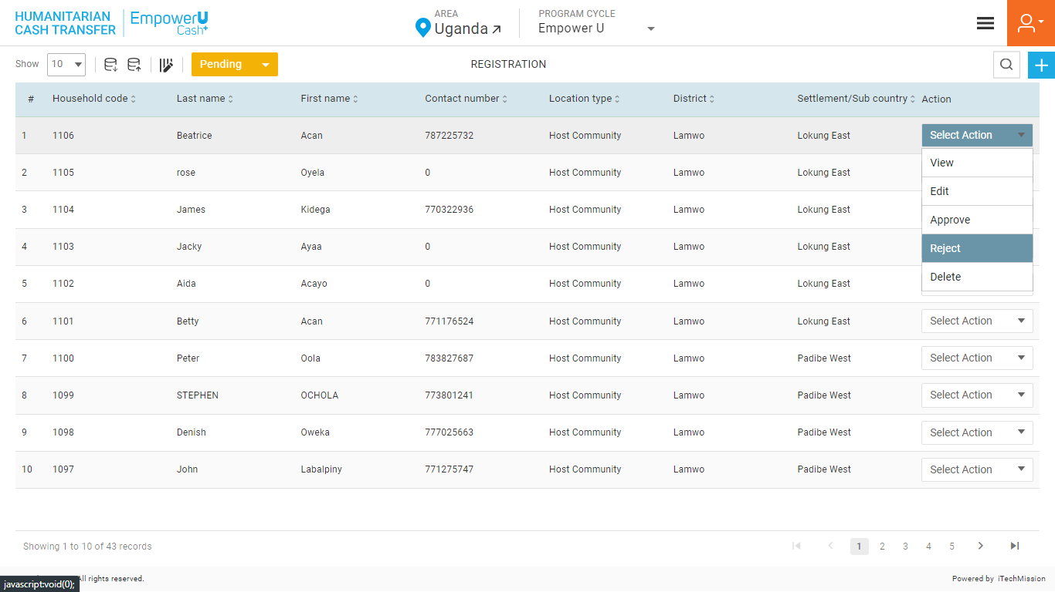In the list of Pending Registrations, click on the **Rejected** option from the action column to approve the selected household. The approved household will be moved to the approved registration list. (see below figure).

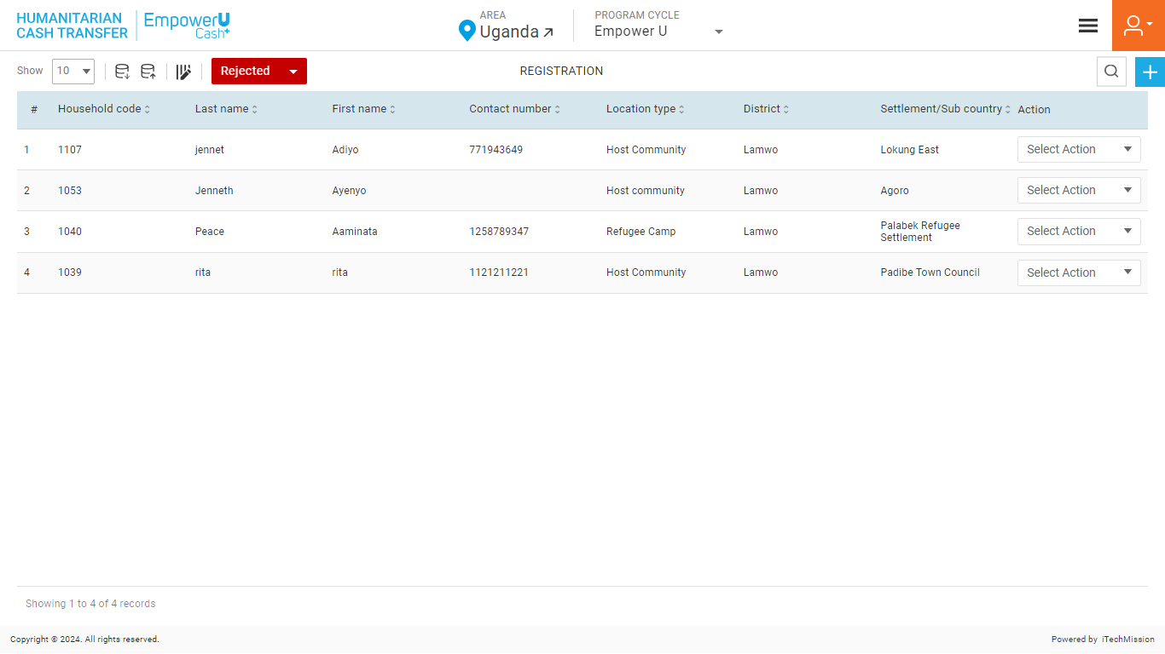The rejected households will be moved to a list of rejected households and notification will be sent to the program officer for the same (see below figure).

Select the **View Profile** option available in the action dropdown to view the profile of the **Approved household**. A view of Respondent Details, Area Specifics, Area Specifics, Verified Status, Member Details, Cash Transfer, Post Distribution Expenditure, Grievance/Complains of the approved household.

Select the **Edit** option available in the action dropdown to edit the details of the selected **household**. Edit the required detail and click on the update button to save and confirm.

Selectthe **Delete** option available in the action dropdown to delete the selected **household**. A confirmation popup will appear, click **Yes** to confirm the deletion of the selected element.

### **6.2.5 GRIEVANCE**

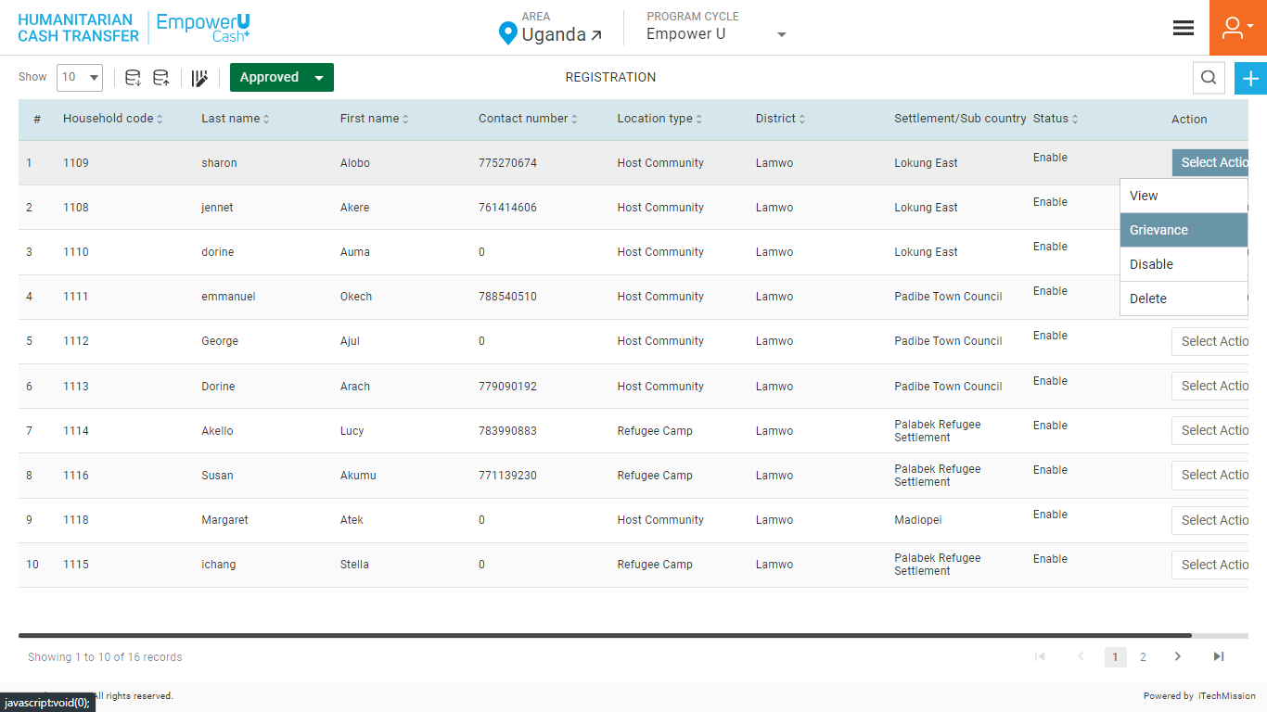Click on the **Grievance** option available on the action dropdown of the selected Approved Registration household.(see below figure).

A popup window will appear to add grievance for the selected Household.(see below figure) 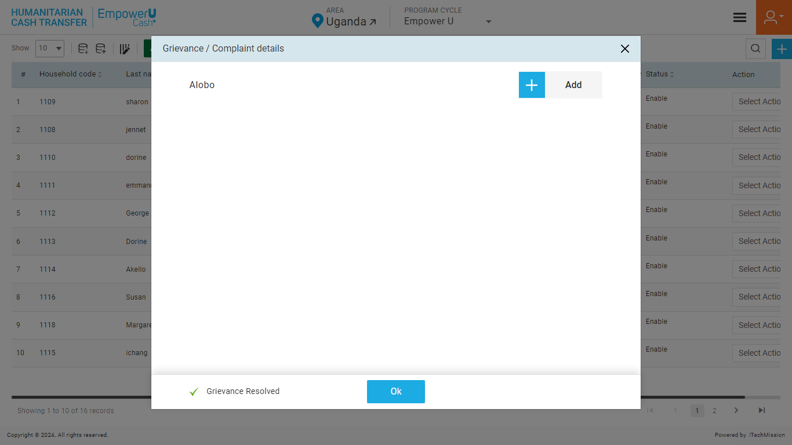

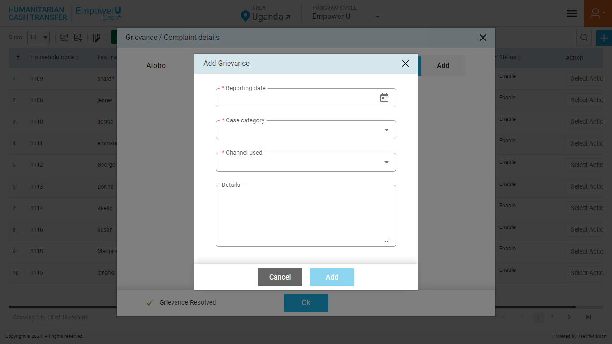Click on the **Plus** button available on the right side of the page to **Add** a new **Grievance** (see figure below)

Enter the following details to add a new grievance:

|  |  |  |  |  |
| --- | --- | --- | --- | --- |
| **Field** | **Type** | **Import Type** | **Mandatory** | **Associated Classification** |
| Reporting date | List | Single Choice | Yes | Location |
| Case category | Text |  | No | Country |
| Channel used |  |  |  |  |
| Details |  |  |  |  |

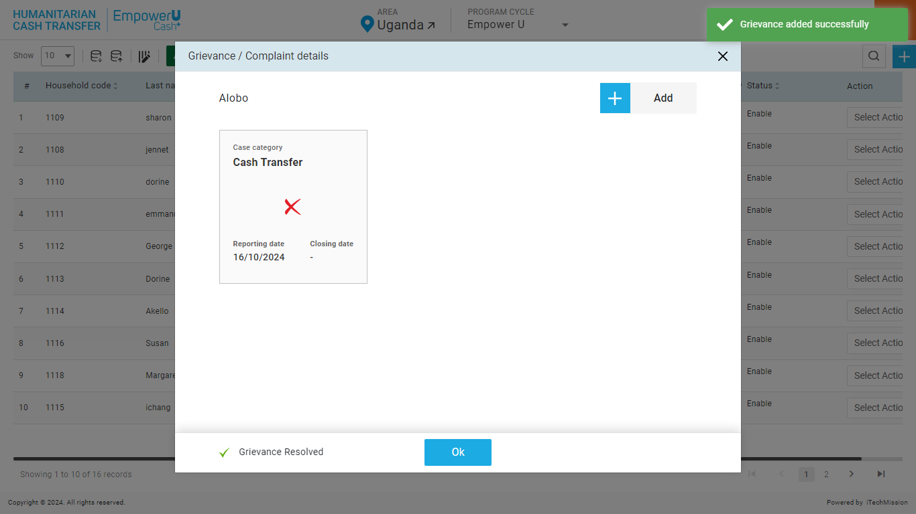Click on the **Add** button to save and confirm. You can now view an open grievance added for the household.(see below figure)

Selectthe **View** option available on the top right corner of the grievance widget to view the grievance details.

Select the **Edit** option available on the top right corner of the grievance widget to edit the details of the selected grievance. Edit the required detail, change the status (closed), add the closing date, and closing remarks, and click on the update button to save and confirm.

Selectthe **Delete** option on the top right corner of the grievance widget to delete the selected element. A confirmation popup will appear, click **Yes** to confirm the deletion of the selected element.

## **6.3 CASH TRANSFER**

Click on the **Cash Transfer** option from Burger menu to access this module. This module is program, installment and cash transfer status driven.and allows you to manage and track cash transfers to registered participants and its approvals. The cash transfer contains four steps for each installment –

1. Eligible

2. Verification

3. Approval

4. Payment

Each cash transfer step has to go through an approval process by authorized users to move forward with the next step. Below are the actions of this module that can be performed by the authorized users –

|  |  |  |  |  |
| --- | --- | --- | --- | --- |
| **Role** | Eligible | Verification | Approval | Payment |
| **Admin** | Checkmark | Checkmark | Checkmark | Checkmark |
| **Program Coordinator** | Checkmark | Checkmark |  |  |
| **Program Manager** | Checkmark |  | Checkmark |  |
| **Program Officer** | Checkmark |  |  | Checkmark |

Select the **Installment** to view the installment-wise eligibility List of the cash transfer

This module facilitates efficient management of household payment information by program cycle. Users can view a paginated list of households along with their payment details, with options to select installments and cash transfer statuses through dropdown menus. The module offers robust search, filter, and navigation features for easy access to information.

### **6.3.1 ELIGIBLE**

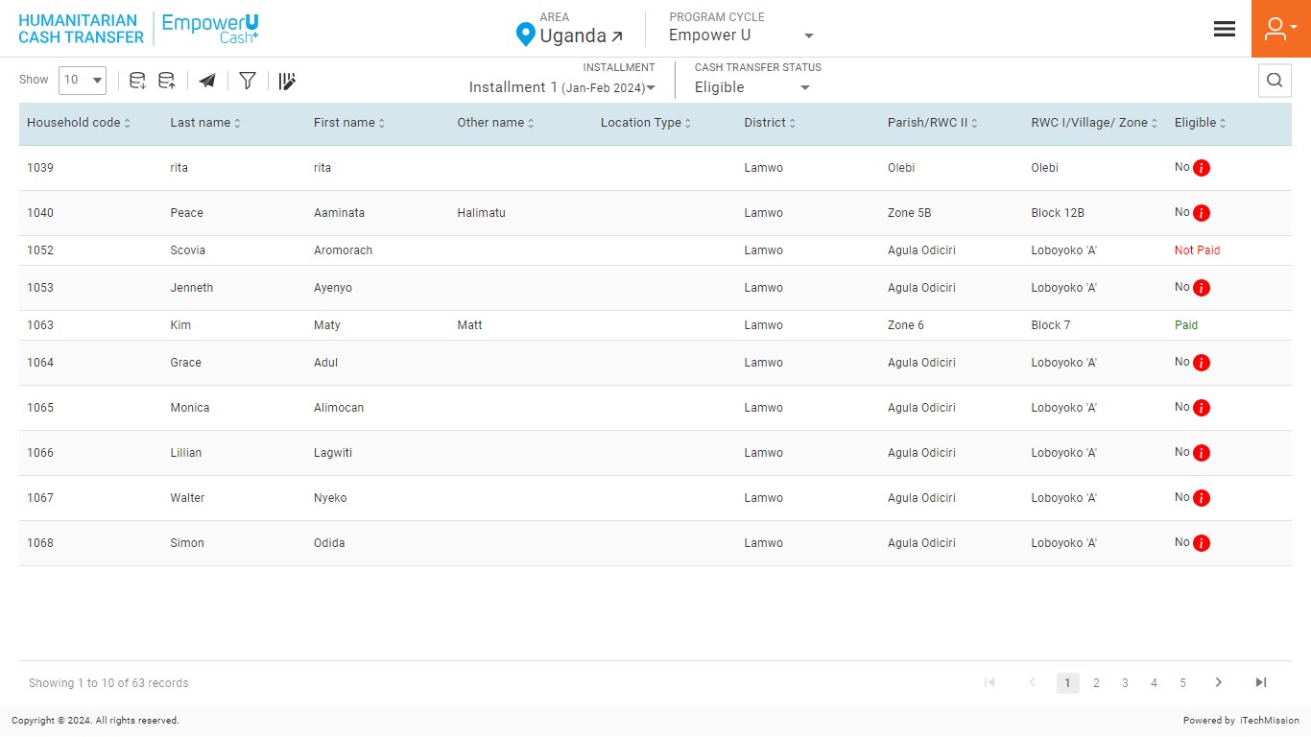The first Cash Transfer step allows you to view the participants’ eligibility list (see below figure). You also have the option to view the reason for the non-eligibility of participants.

*Hover over the Information button from the Eligible column to view the reason for the eligible status of the selected household to be No.*

#### EXPORT

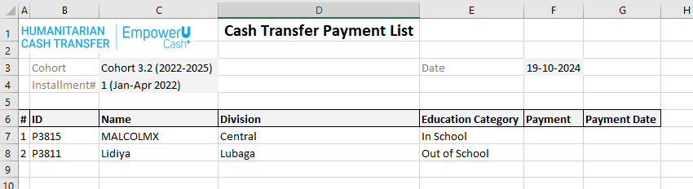Click on the **Export** button to download to download the household's eligibility data available in the database (See below figure).

Below is the area structure that you will find in the Cash Transfer template.

**General Information**

|  |  |
| --- | --- |
| **ProgramCycle** | The cycle in which a household is enrolled |
| **Household ID** | Unique ID for every household |
| **Location** | Location of the household *(select from the Host Community and Refugee Camp)* |
| **CountryOfOrigin** | In the case of Location Refugee camp, select the origin. |

*The list is exported in the CSV (Comma Separated Value) file format.*

#### FILTER

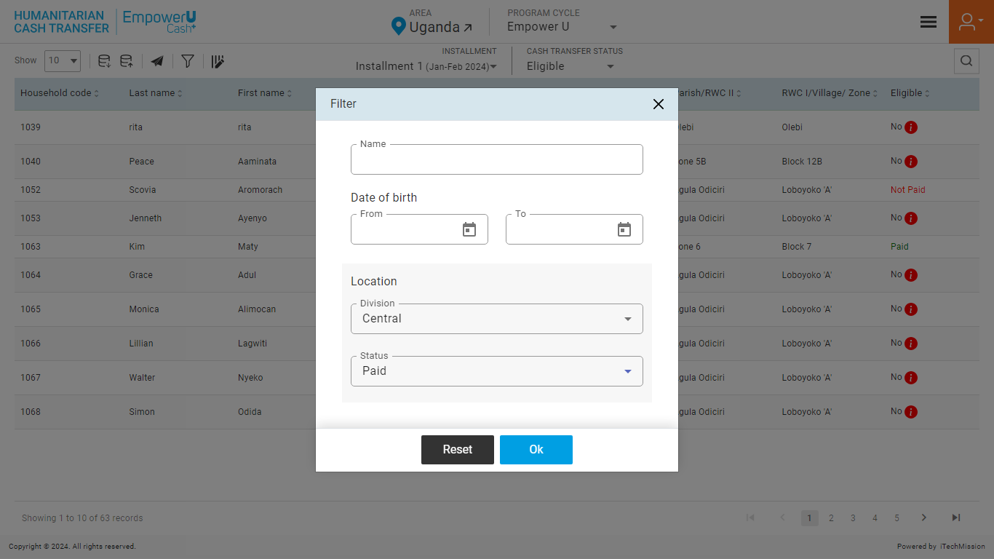Click on the **Filter** button available on the left side of the page to filter the household list based on the specified criteria.(See below figure).

Suppose you want to filter the household where the “Division – Central” and “State – Paid”.

Click on the **Add** button to confirm saving the filter. This will filter the List and show records following the applied criterion.

Click on the **Reset** button to empty the applied criterion. This will remove the filters applied to the Cash Transfer List.

### **6.3.2 VERIFICATION**

In this step of the **Cash Transfer** process, the eligible participants have to be verified by the Admin or the Program Coordinator to move to the next step of cash transfer process (see below figure). 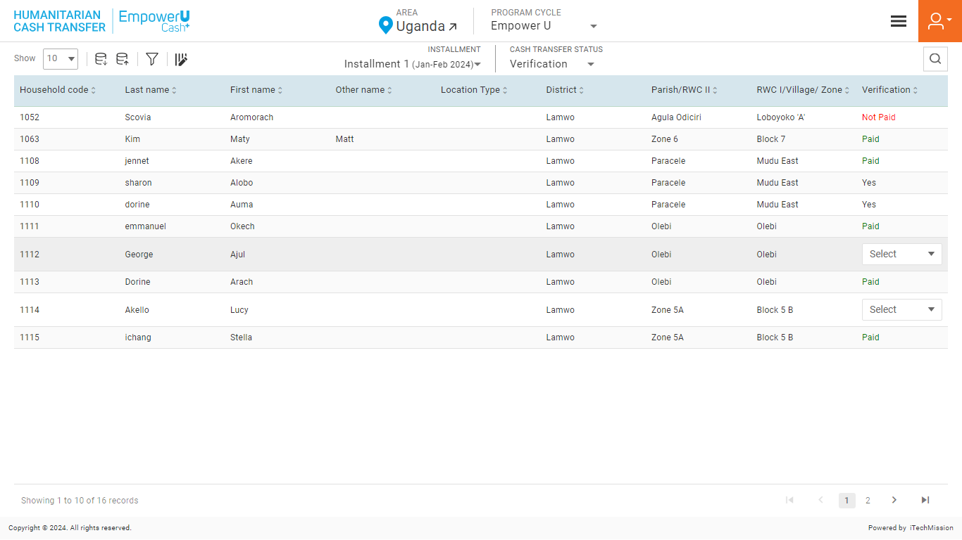

Click on the **Cash Transfer Status** dropdown available on the navigation panel and Select the Verification option.

Click on the **Select** dropdown and select one of the options from **Yes or No** to complete the verification of the selected **Household**. If clicked Yes, the household is verified and will be moved to the next cash transfer process.

#### EXPORT

Click on the **Export** button to download to download the household's eligibility data available in the database (See below figure).

Below is the area structure that you will find in the Cash Transfer template.

**General Information**

|  |  |
| --- | --- |
| **ProgramCycle** | The cycle in which a household is enrolled |
| **Household ID** | Unique ID for every household |
| **Location** | Location of the household *(select from the Host Community and Refugee Camp)* |
| **CountryOfOrigin** | In the case of Location Refugee camp, select the origin. |

*The list is exported in the CSV (Comma Separated Value) file format.*

#### IMPORT

Click on the **Import** button to browse the file and upload the household list into the database. (See below figure).

To complete the first verification process of bulk households at once, you can edit the downloaded verification file and enter one of the options (Yes or No) in the Verification column. Save the file in CSV format and click on the import option to browse the saved file and upload.

To upload the household list into the Cash Transfer Module, click on the **Browse File** button to select the file. Then, click on the **Upload** button to start the import process.

#### FILTER

Click on the **Filter** button available on the left side of the page to filter the household list based on the specified criteria.(See below figure).

Suppose you want to filter the household where the “Division – Central” and “State – Paid”.

Click on the **Add** button to confirm saving the filter. This will filter the List and show records following the applied criterion.

Click on the **Reset** button to empty the applied criterion. This will remove the filters applied to the Cash Transfer List.

### **6.3.3 APPROVAL**

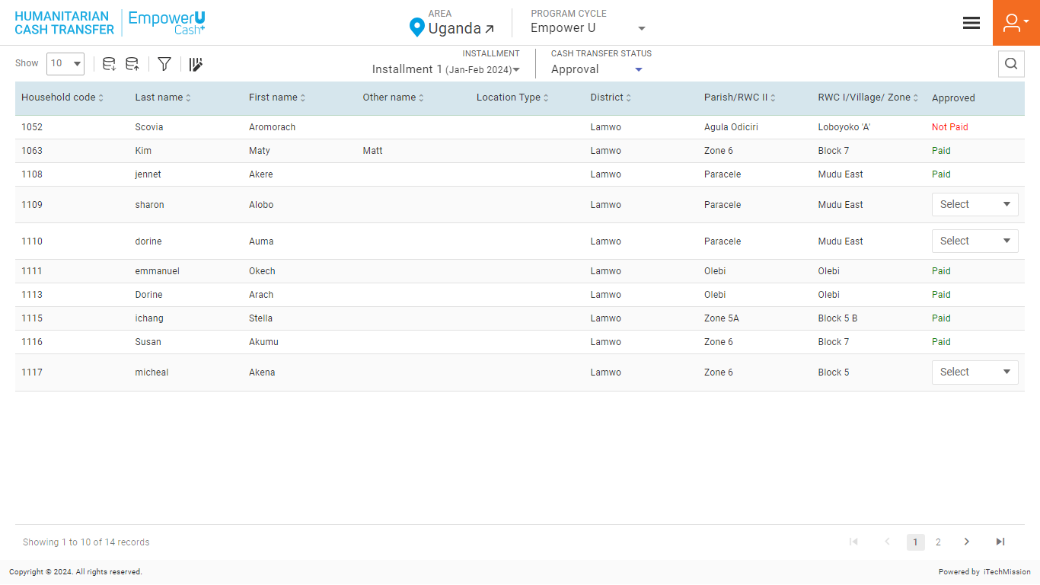In the second step of cash transfer process, Admin or the Program Manager will approve the payment of the participants whose second verification is completed You will receive notification when the participants will be moved to the approval step of cash transfer process. Click on the **bell** button to view the received notification in the cash transfer category (see below figure).

Click on the **Cash Transfer Status** dropdown available on the navigation panel and Select the Verification option.

Click on the **Select** dropdown and select one of the options from **Yes or No** to complete the verification of the selected **Household**. If clicked Yes, the household is verified and will be moved to the next cash transfer process.

#### EXPORT

Click on the **Export** button to download to download the household's eligibility data available in the database (See below figure).

Below is the area structure that you will find in the Cash Transfer template.

**General Information**

|  |  |
| --- | --- |
| **ProgramCycle** | The cycle in which a household is enrolled |
| **Household ID** | Unique ID for every household |
| **Location** | Location of the household *(select from the Host Community and Refugee Camp)* |
| **CountryOfOrigin** | In the case of Location Refugee camp, select the origin. |

*The list is exported in the CSV (Comma Separated Value) file format.*

#### IMPORT

Click on the **Import** button to browse the file and upload the household list into the database. (See below figure).

To complete the first verification process of bulk households at once, you can edit the downloaded verification file and enter one of the options (Yes or No) in the Verification column. Save the file in CSV format and click on the import option to browse the saved file and upload.

To upload the household list into the Cash Transfer Module, click on the **Browse File** button to select the file. Then, click on the **Upload** button to start the import process.

#### FILTER

Click on the **Filter** button available on the left side of the page to filter the household list based on the specified criteria.(See below figure).

Suppose you want to filter the household where the “Division – Central” and “State – Paid”.

Click on the **Add** button to confirm saving the filter. This will filter the List and show records following the applied criterion.

Click on the **Reset** button to empty the applied criterion. This will remove the filters applied to the Cash Transfer List.

### **6.3.4 PAYMENT**

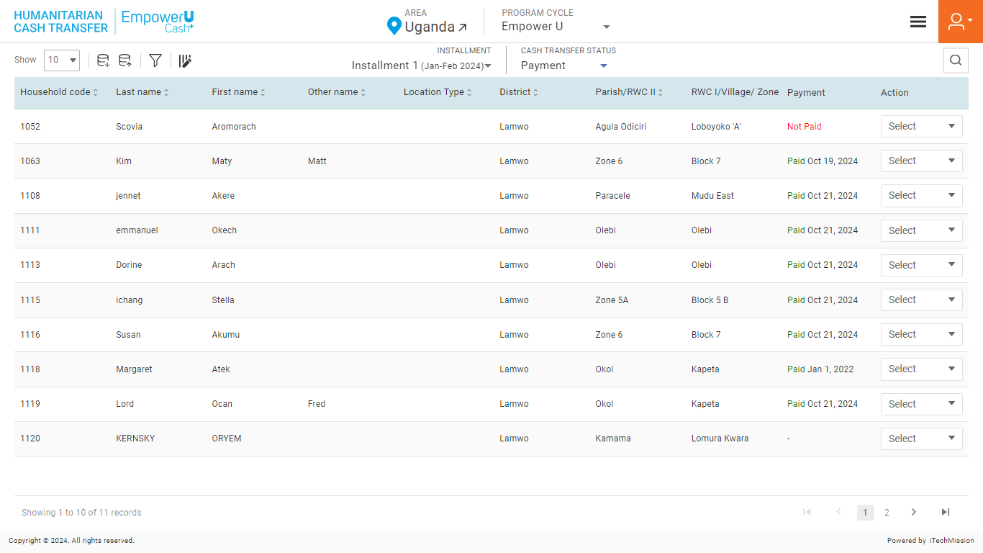In the last step of the cash transfer process, the admin or the Treasury will update the payment status of the approved participants. (see below figure).

Click on the **Cash Transfer Status** dropdown available on the navigation panel and Select the Payment option.

Click on the **Select** dropdown and select Pay to update the payment status to complete the payment of the selected **Household**.

A payment popup window appears, click on the payment status dropdown and select one of the options from Yes or No. If clicked Yes, enter the payment date and click on OK to confirm (see below figure). 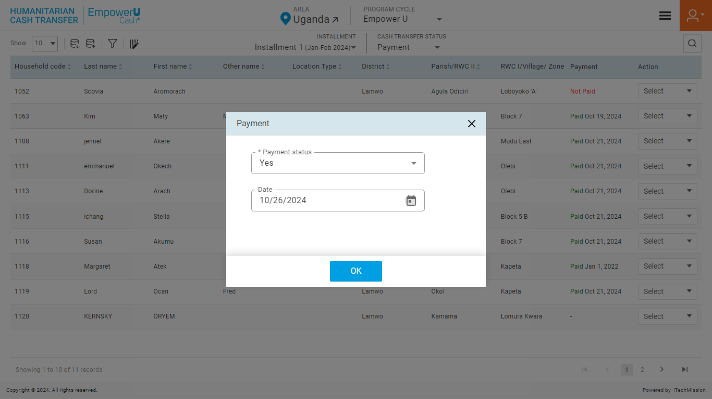

#### EXPORT

Click on the **Export** button to download to download the household's eligibility data available in the database (See below figure).

Below is the area structure that you will find in the Cash Transfer template.

**General Information**

|  |  |
| --- | --- |
| **ProgramCycle** | The cycle in which a household is enrolled |
| **Household ID** | Unique ID for every household |
| **Location** | Location of the household *(select from the Host Community and Refugee Camp)* |
| **CountryOfOrigin** | In the case of Location Refugee camp, select the origin. |

*The list is exported in the CSV (Comma Separated Value) file format.*

#### IMPORT

Click on the **Import** button to browse the file and upload the household list into the database. (See below figure).

To update the payment status of bulk participants at once, you can edit the downloaded payment file and enter one of the options (Yes or No) in the Payment column. In case the payment status is yes, also enter the date of payment in the respective column. Save the file in CSV format and click on the import option to browse the saved file and upload .

To upload the household list into the Cash Transfer Module, click on the **Browse File** button to select the file. Then, click on the **Upload** button to start the import process.

#### FILTER

Click on the **Filter** button available on the left side of the page to filter the household list based on the specified criteria.(See below figure).

Suppose you want to filter the household where the “Division – Central” and “State – Paid”.

Click on the **Add** button to confirm saving the filter. This will filter the List and show records following the applied criterion.

Click on the **Reset** button to empty the applied criterion. This will remove the filters applied to the Cash Transfer List.

## **6.4 POST DISTRIBUTION EXPENDITURE**

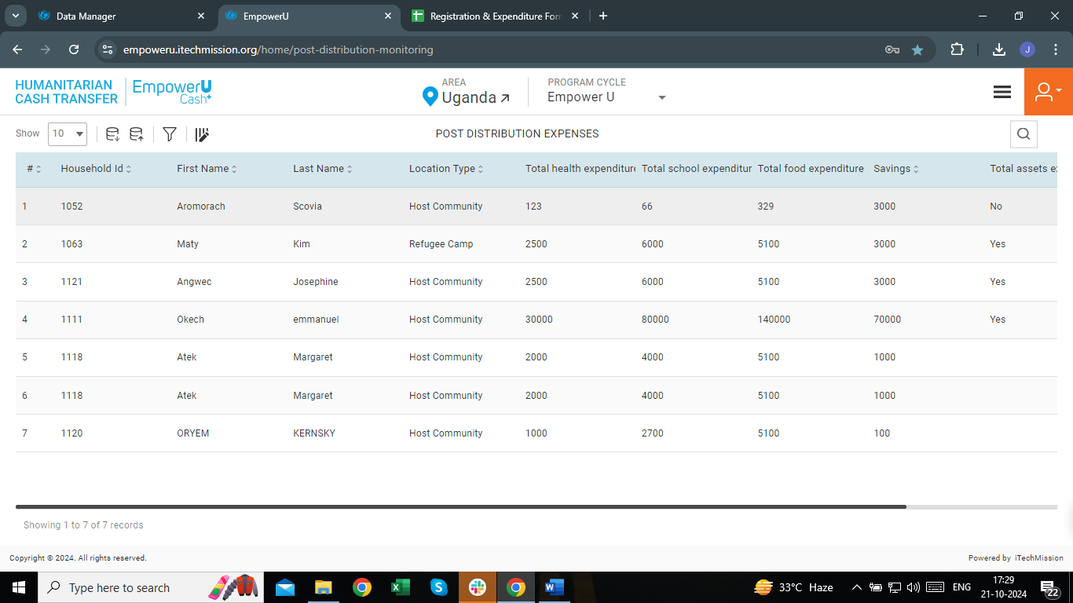Click on the **Burger menu icon** located in the top right corner of the home page, and select the **Post Distribution Expenditure** option (see figure below).

This Module provides a comprehensive overview of household expenditure information, displaying existing data in a paginated table format that allows for easy navigation and customization. Users can efficiently search and sort through the list to find relevant entries.

### **6.4.1 EXPORT**

Click on the **Export** button to download the empty household Registration template and household data available in the database (See below figure).

Below is the area structure that you will find in the Registration template.

**Health, Education, and Food Expenditure:**

**Health Expenditure (in UGX)**

|  |  |
| --- | --- |
| **ProgramCycle** | The cycle in which a household is enrolled |
| **RespondentID** | Unique ID for every household respondent |
| **ChildHealthCare** | Cost spent for Child Health Care |

**Education Expenditure (in UGX)**

|  |  |
| --- | --- |
| **SchoolFees** | Cost spent for School Fees |
| **SchoolUniforms** | Cost spent for School Uniforms |
| **SchoolasticMaterials** | Cost spent for Scholastic materials |
| **SchoolExpenditure** | Cost spent for School Expenditure |

**Food Expenditure (in UGX)**

|  |  |
| --- | --- |
| **Vegetables** | Cost spent for School Expenditure |
| **Milk** | Cost spent for School Expenditure |
| **Cereals** | Cost spent for School Expenditure |
| **Eggs** | Cost spent for School Expenditure |
| **Porridge** | Cost spent for School Expenditure |
| **FoodExpenditure** | Cost spent for School Expenditure |

**Savings (in UGX)**

|  |  |
| --- | --- |
| **Savings** | Cost spent for School Expenditure |
| **IncomeGeneratingActivities** | Is there any income generating Activity – YES/NO |
| **AssetsAcquiredFromSavings** | Is there any asset acquired from savings – YES/NO |
| **OtherHouseholdIncomeSources** | Is there any other household Income Sources– YES/NO |

**EmpowerU cash project training:**

|  |  |
| --- | --- |
| **GrievanceRedressManagement** | Was Grievance Redress Management training done – YES/NO |
| **FinancialLiteracy** | Was Financial literacy training done – YES/NO |
| **GenderBasedViolence** | Was gender-based violence training done – YES/NO |
| **OtherTrainingType** | In case of other training done, mention the type. |

Click on the **Empty** button to download an empty registration template use this template to create the registration data of the potential household. (see below figure). 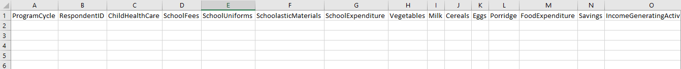

Click on the **With Data** button to download the registration data available in the database (see below figure). 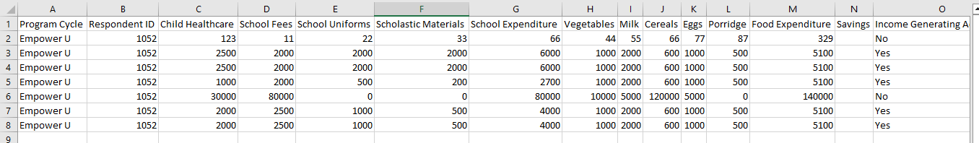

*The list is exported in the CSV (Comma Separated Value) file format.*

### **6.4.2 IMPORT**

Click on the **Import** button to browse the file and upload the household list into the database. (See below figure).

To upload the household list into the database, enter the household details in the epmty template above and then click on the **Browse File** button to select the template. Then, click on the **Upload** button to start the import process.

*The records which contain blank entries, entries with special characters, and duplicate entries will not be imported into the database.*

The Last Upload summary provides the count of total and imported records. A log will be generated for the failed records which were duplicated, failed, successfully inserted, and updated into the database out of the total records.

### **6.4.3 ADD**

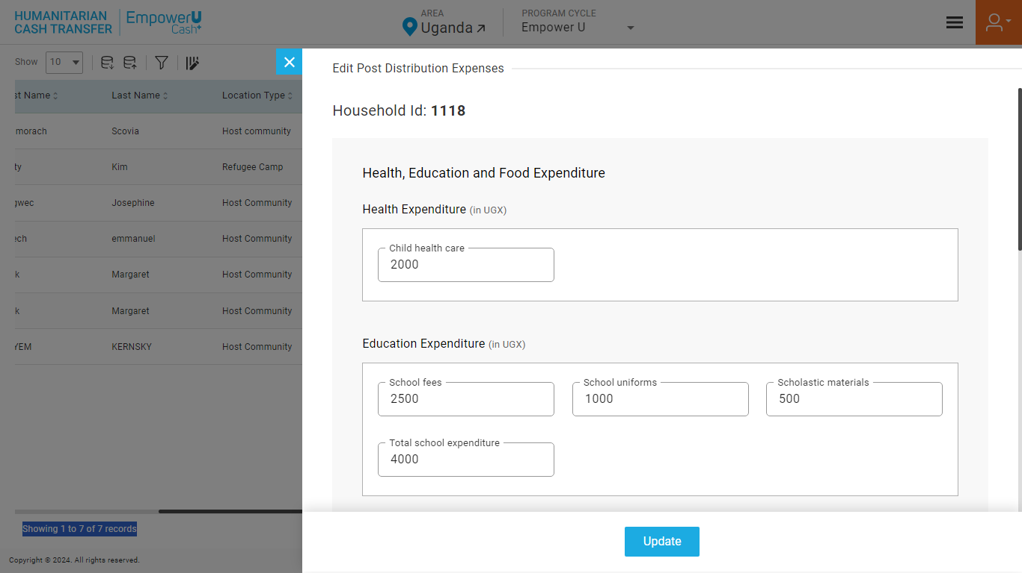A household will be visible on the Post Distribution Expenditure when the Cash Transfer Payment is completed and savings will exist. For new households, the Add option will be available to add the Expenditure for the payment made in the program. (see figure below)

Enter the following details to add a new Household.

**Health, Education, and Food Expenditure:**

**Health Expenditure (in UGX)**

|  |  |  |  |  |
| --- | --- | --- | --- | --- |
| **Field** | **Type** | **Import Type** | **Mandatory** | **Associated Classification** |
| **Child health care** | Numeric |  | No |  |

**Education Expenditure (in UGX)**

|  |  |  |  |  |
| --- | --- | --- | --- | --- |
| **School fees** | Numeric |  | No |  |
| **School uniforms** | Numeric |  | No |  |
| **Scholastic materials** | Numeric |  | No |  |
| **Total school expenditure** | Derived | The sum of School fees, School uniforms, and scholastic material | No |  |

**Food Expenditure (in UGX)**

|  |  |  |  |  |  |
| --- | --- | --- | --- | --- | --- |
| **Vegetables** | Numeric |  | No | |  |
| **Milk** | Numeric |  | | No |  |
| **Cereals** | Numeric |  | | No |  |
| **Eggs** | Numeric |  | No | |  |
| **Porridge** | Numeric |  | No | |  |
| **Total food expenditure** | Derived | The sum of Vegetable, Milk, Cereals, Egg, and Porridge. | No | |  |

**Savings (in UGX)**

|  |  |  |  |  |  |  |  |
| --- | --- | --- | --- | --- | --- | --- | --- |
| **Money saved** | Numeric |  | | No | |  | |
| **Income-generating activities (IGA)** | Checkbox | | Single Choice | | Yes | |  | |
| **Assets acquired from savings** | Checkbox | Single Choice | | Yes | |  | |
| **Other sources of income** | Checkbox | Single Choice | | Yes | |  | |

**EmpowerU cash project training:**

|  |  |  |  |  |
| --- | --- | --- | --- | --- |
| **Grievance redress management** | Checkbox | Single Choice | No |  |
| **Gender-based violence** | Checkbox | Single Choice | No |  |
| **Other** | Checkbox | Single Choice | No |  |
| **Other training** | Text | Single Choice | No |  |

Click on the **Save** button to save and confirm. You can now view the households added in the registration list (see below figure).

*The registered household will remain in pending state until approved by the program manager.*

Click the **Search** button and specify the name to view entries.

Selectthe **View** option available in the action dropdown to view the details of the selected element.

Select the **Edit** option available in the action dropdown to edit the details of the selected element. Edit the required detail and click on the update button to save and confirm.

Selectthe **Delete** option available in the action dropdown to delete the selected element. A confirmation popup will appear, click **Yes** to confirm the deletion of the selected element.

Select the **Enable/Disable** option available in the action dropdown to show or hide the specific element. The hidden element will not be shown in the list of selected Area types overall in the application.

## **7.0 ADMIN**

The **Admin** module comprises various data management sub-modules. These sub-modules allow the creation and management of the master data. Following are the data management sub-modules

* Summary
* Area
* Classification
* Program Cycle
* User
* Report
* Resource
* Keyfacts
* Import Logs

Let us understand and learn how to use these sub-modules.

### **7.1** **SUMMARY**

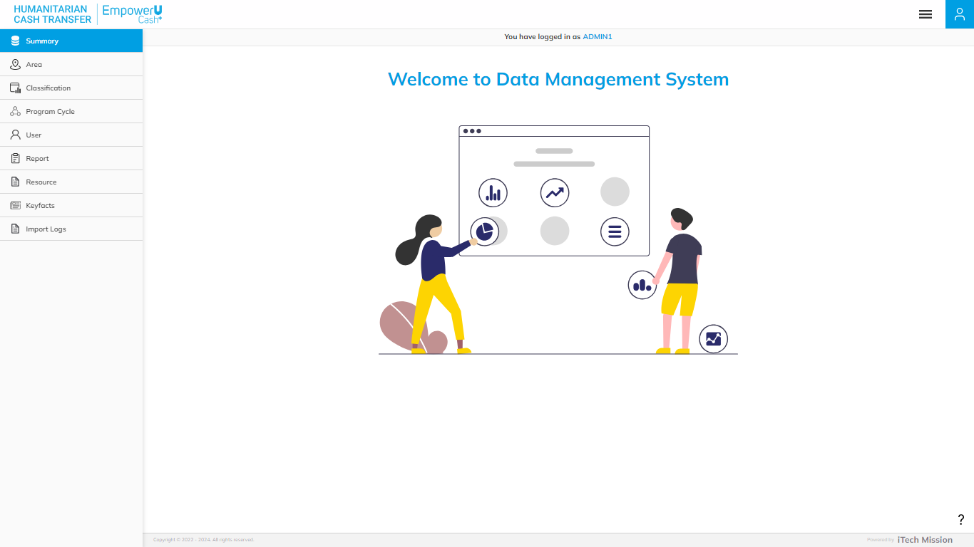The first sub-module is the **Summary.** You can also access this module by clicking on the **Summary** menu option in the left panel. This module depicts the following information from the database. (see below figure).

1. **Program Cycle**

The first widget shows the total count of programs and the count of participants available in the database and the last date when the program and households list were updated.

1. **Area**

The next widget shows the total count of geographical areas along with the count of areas which falls under area level 1 to level 5 available in the database and the last date when the area details were updated.

1. **Classification**

The first box in next row shows the total count master list available in the database and the last date when the master list was updated.

1. **User**

The next box shows the total count of users along with count of users by user role partner, peer mentor and lead mentor available in the database and the last date when the user details were updated.

1. **Resource**

The last box shows the total count of resources available in the database and the last date when the resources were updated.

### **7.2 AREA**

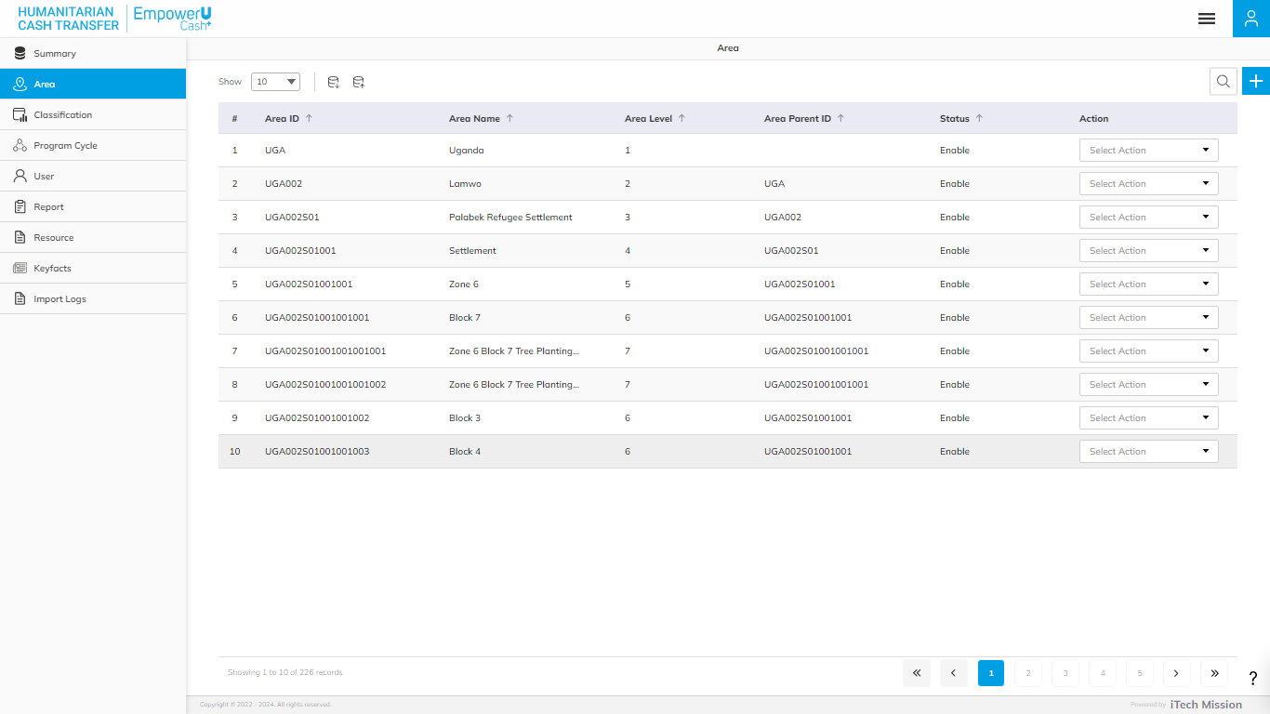Click on the **Area** module option in the left navigation panel. This module allows to manage the **Area** master list. You will have options to export and import an area template, add a new area, view the list of existing areas, sort the list, search areas from the list, and delete, edit update existing areas (see figure below).

#### **EXPORT AREA**

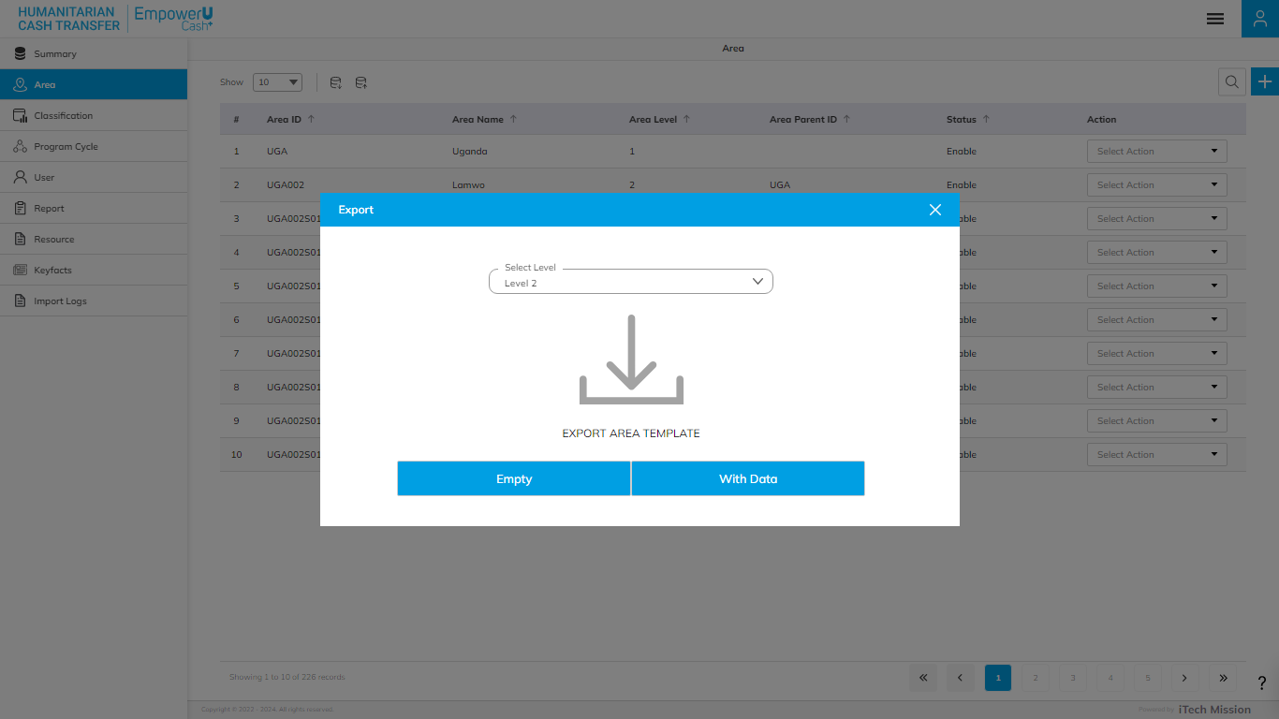Click on the **Export** button to the empty area template and area list available in the database. (See below figure).

You can use this option to create an area structure. Below is the area structure that you will find in the area template.

|  |  |
| --- | --- |
| AreaID | A unique area identification that associates the area to its map. |
| AreaName | Area Name assigned to an area. |
| AreaLevel | The level number is assigned in the area hierarchy. |
| AreaParentID | AreaID of the parent area. |
| AreaGroup | Group of the Area |

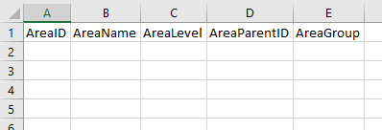By clicking on the **Empty** button, you can download an empty area template (see below figure).

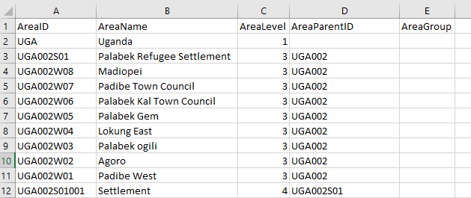Click on the **With Data** button of the download box to download the area list available in the database (see below figure).

*The list is exported in the CSV (Comma Separated Value) file format.*

#### **IMPORT AREA**

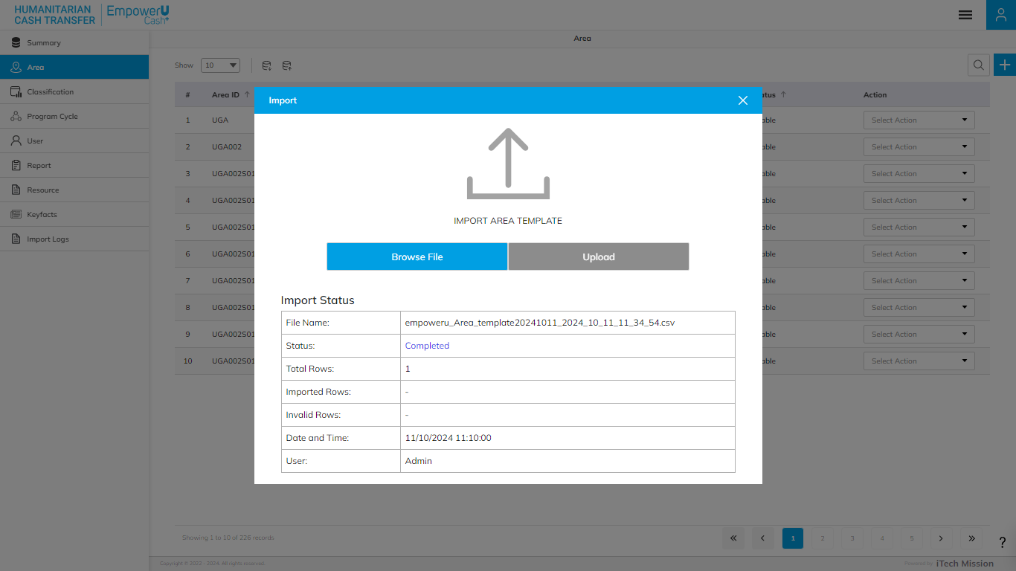Click on the **Import** button to browse the file and upload the household list into the database. (see below figure)

To upload the area into the database first enter the area structure in the template as explained above and then click on the **Browse File** button to select the template. Now, click on the **Upload** button to start the import process.

*During the import process, the records which contain blank entries, entries with special characters, and duplicate entries are not imported into the database.*

The Last Upload summary provides the count of total and imported records. A log will be generated for the failed records which were duplicated, failed, successfully inserted, and updated into the database out of the total records.

#### **ADD AREA**

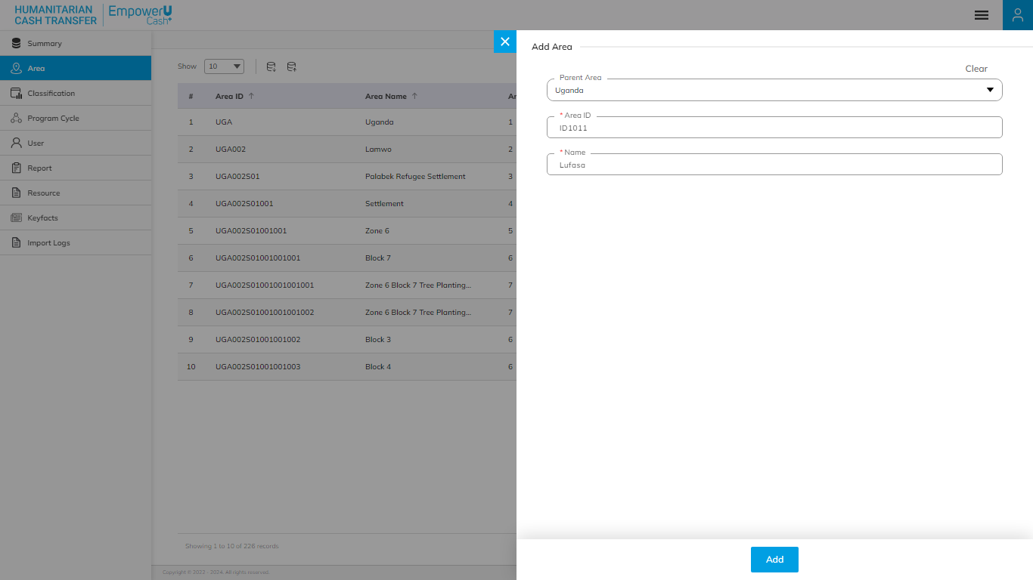Click on the **Plus** button available on the right side of the page to **Add** a new **Area** (see figure below).

Enter the following details to add a new **Area**:

|  |  |  |  |  |
| --- | --- | --- | --- | --- |
| **Field** | **Type** | **Import Type** | **Mandatory** | **Associated Classification** |
| **Parent Area** | List | Single Choice | No | Area Level List |
| **Area ID** | Text |  | Yes |  |
| **Name** | Text |  | Yes |  |

Click on the **Add** button to save and confirm. You can now view the new **Area** added to the **Area** list.

Click the **Search** button and specify the name to view entries.

Selectthe **View** option available in the action dropdown to view the details of the selected element.

Select the **Edit** option available in the action dropdown to edit the details of the selected element. Edit the required detail and click on the update button to save and confirm.

Selectthe **Delete** option available in the action dropdown to delete the selected element. A confirmation popup will appear, click **Yes** to confirm the deletion of the selected element.

Select the **Enable/Disable** option available in the action dropdown to show or hide the specific element. The hidden element will not be shown in the list of selected Area types overall in the application.

### **7.3 CLASSIFICATION**

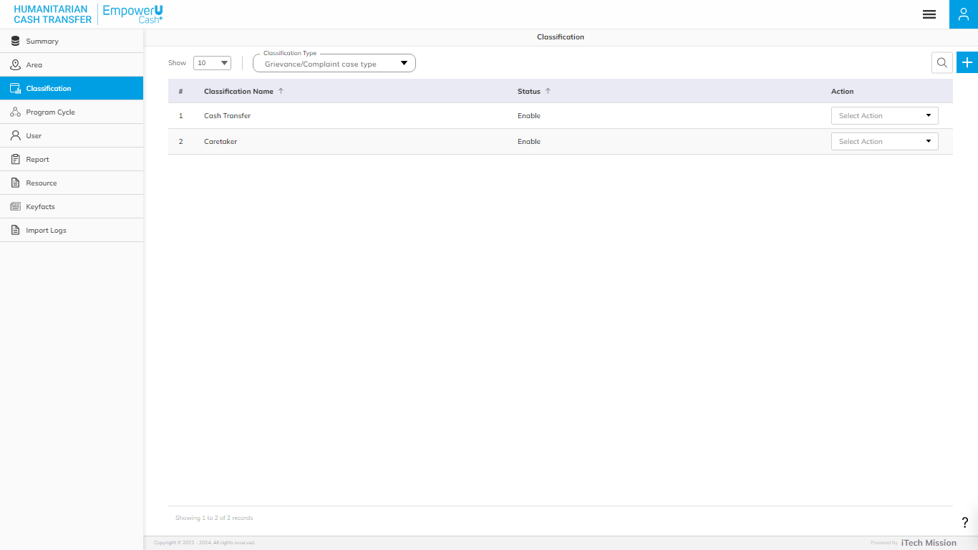Click on the **Classification** module option in the left navigation panel. This module allows you to manage the **Classification** list of available types You will have options to add new elements to all the types of **Classification** lists, view the list by types, sort each list, search elements of selected type from the list, edit and enable/disable existing elements of selected type from the list (see figure below).

#### **ADD CLASSIFICATION**

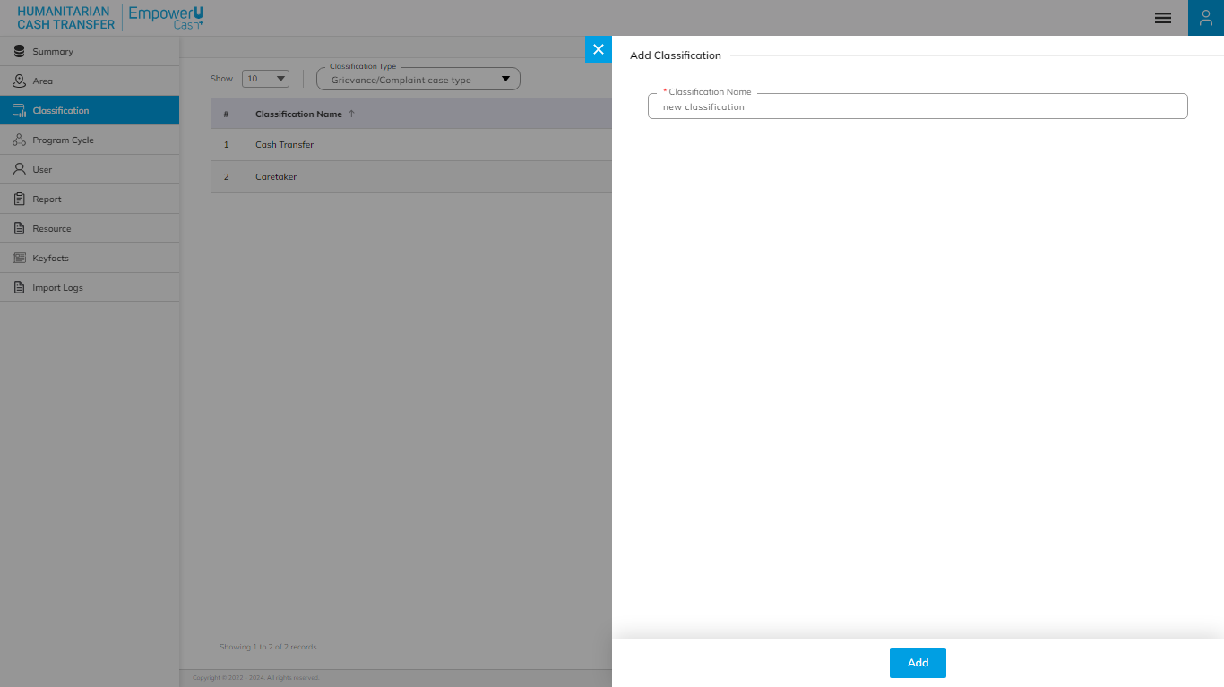Click on the **Plus** button available on the right side of the page to **add** a new classification (see figure below).

Select the **Classification** type and enter the Classification Name to be added to the master list of selected types.

Click on the **Add** button to save and confirm. You can now view the new **Area** added to the **Area** list.

Click the **Search** button and specify the name to view entries.

Selectthe **View** option available in the action dropdown to view the details of the selected element.

Select the **Edit** option available in the action dropdown to edit the details of the selected element. Edit the required detail and click on the update button to save and confirm.

Selectthe **Delete** option available in the action dropdown to delete the selected element. A confirmation popup will appear, click **Yes** to confirm the deletion of the selected element.

Select the **Enable/Disable** option available in the action dropdown to show or hide the specific element. The hidden element will not be shown in the list of selected Area types overall in the application.

### **7.4 PROGRAM CYCLE**

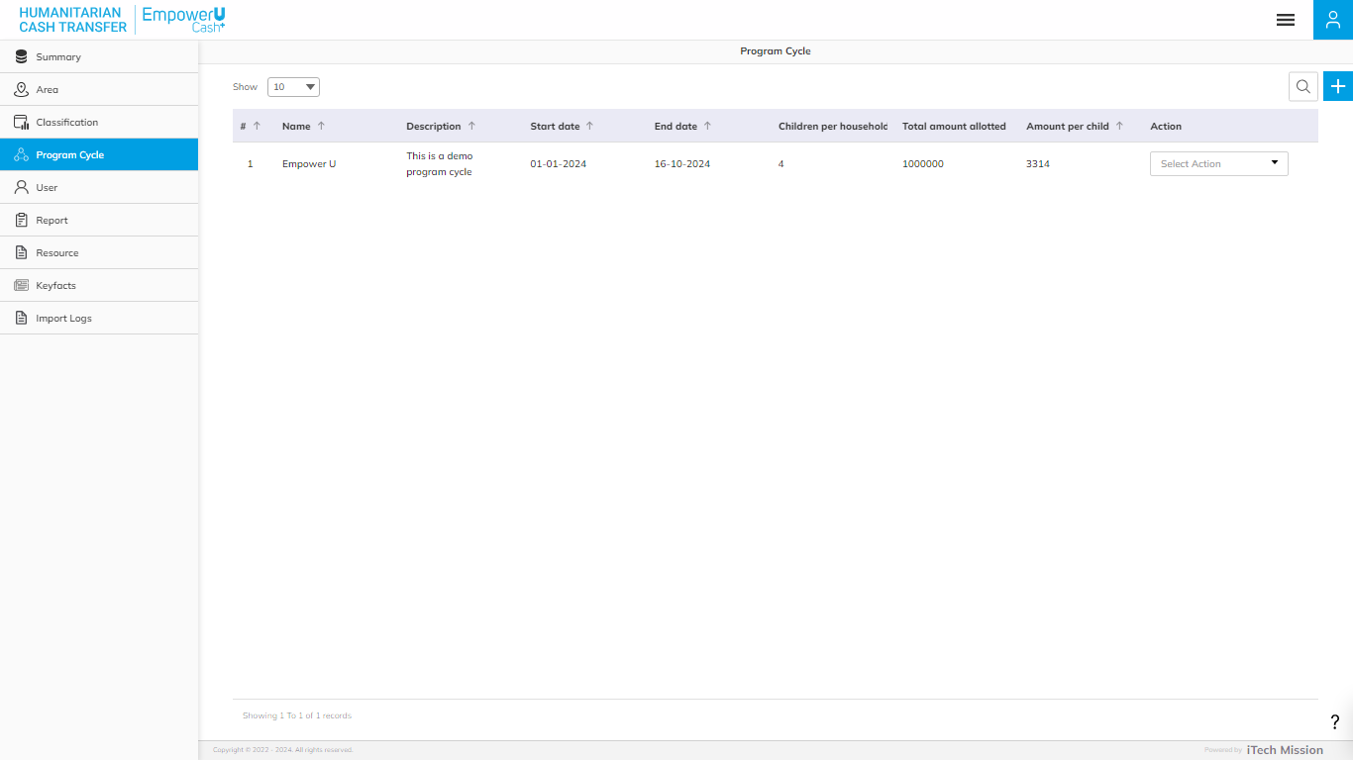Click on the **Program Cycle** module option in the left navigation panel. This module allows you to manage the **Program Cycle** list. You will have options to add new programs, view the list of existing programs, sort the list, search program from the list, delete, edit, and enable/disable existing programs (see figure below).

#### **ADD PROGRAM CYCLE**

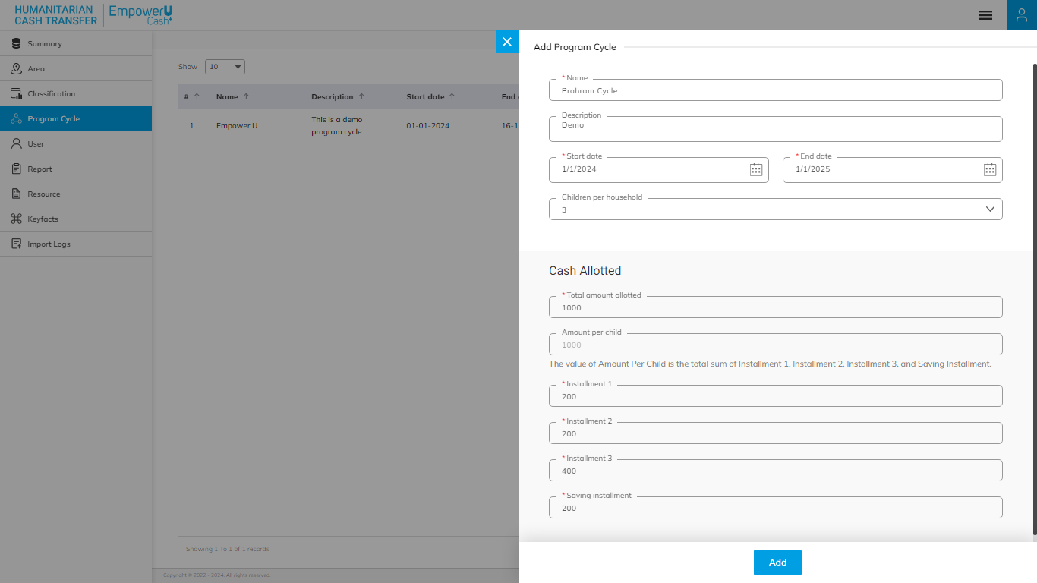Click on the **Plus** button available to the right side of the page to **add** a new program (see figure below).

Enter the following details to add new **Program Cycle**.

|  |  |  |  |  |
| --- | --- | --- | --- | --- |
| **Field** | **Type** | **Import Type** | **Mandatory** | **Associated Classification** |
| **Name** | Text |  | Yes |  |
| **Description** | Text |  | No |  |
| **Start Date** | Date |  | Yes |  |
| **End Date** | Date |  | Yes |  |
| **Children per household** | List | Single Choice | No | static |

**Cash Allotted**

|  |  |  |  |  |
| --- | --- | --- | --- | --- |
| **Total amount allotted** | Text |  | Yes |  |
| **mount per child** | Derived | The value of Amount Per Child is the total sum of Installment 1, Installment 2, Installment 3, and Saving Installment. | Derived |  |
| **Installment 1** | Numeric |  | Yes |  |
| **Installment 2** | Numeric |  | Yes |  |
| **Installment 3** | Numeric |  | Yes |  |
| **Saving installment** | Numeric |  | Yes |  |

Click on the **Add** button to save and confirm. You can now view the new **Program Cycle** added to thelist.

Click the **Search** button and specify the name to view entries.

Selectthe **View** option available in the action dropdown to view the details of the selected element.

Select the **Edit** option available in the action dropdown to edit the details of the selected element. Edit the required detail and click on the update button to save and confirm.

Selectthe **Delete** option available in the action dropdown to delete the selected element. A confirmation popup will appear, click **Yes** to confirm the deletion of the selected element.

Select the **Enable/Disable** option available in the action dropdown to show or hide the specific element. The hidden element will not be shown in the list of selected Area types overall in the application.

### **7.5 USER**

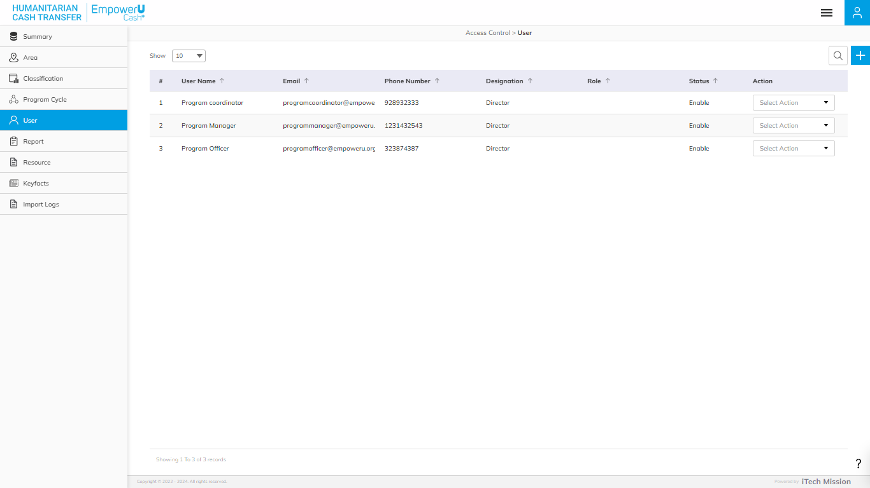click on the **User** module option in the left navigation panel. This module allows you to manage the **User** master list. You will have options to add new users, view the list of existing users, search users from the list, and edit and enable/disable existing users (see figure below).

#### **ADD USER**

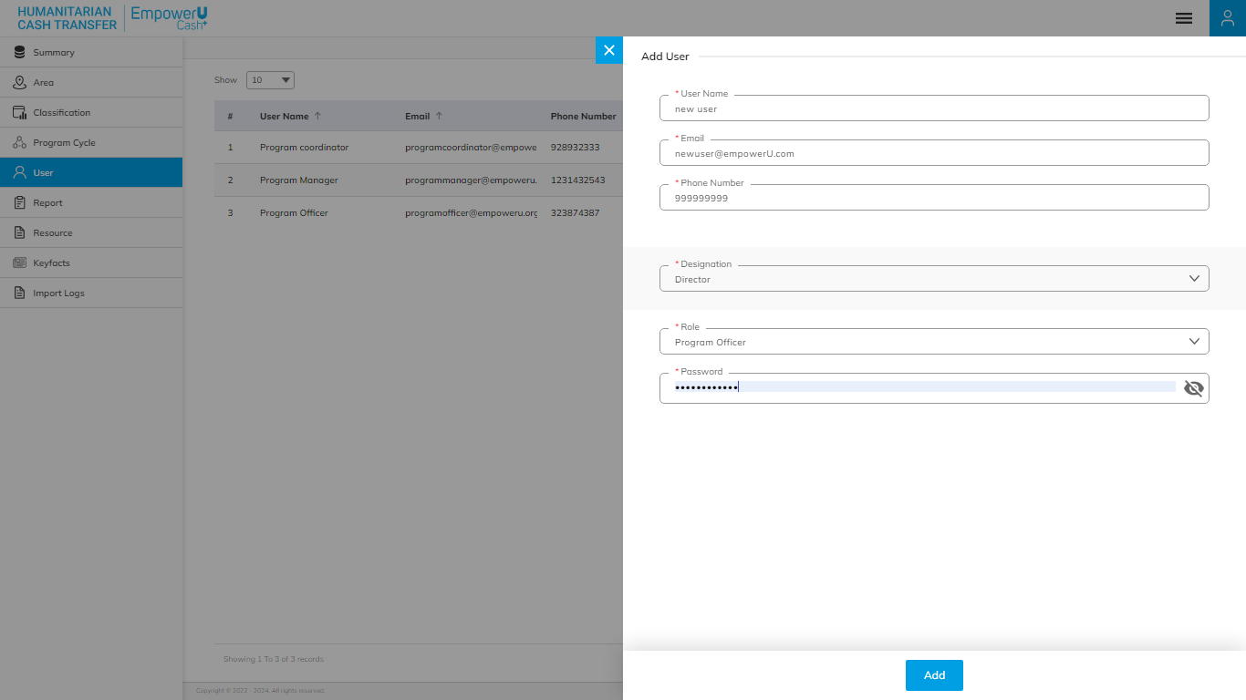Click on the **Plus** button available to the right side of the page to add new user (see figure below).

You can create a new User and assign them one of the roles.

1. Program Officer
2. Program Co-Ordinator
3. Program Manager
4. Treasury

Enter the following details to create a new **User**:

|  |  |  |  |  |
| --- | --- | --- | --- | --- |
| **Field** | **Type** | **Import Type** | **Mandatory** | **Associated Classification** |
| **User Name** | Text |  | Yes |  |
| **Email** | Text |  | Yes |  |
| **Phone Number** | Numeric |  | Yes |  |
| **Designation** | List | Single Choice | Yes | Designation |
| **Role** | List | Single Choice | Yes | static |
| **Password** | Text |  | Yes |  |

Click on the **Add** button to save and confirm. You can now view the new **User** added to thelist.

Click the **Search** button and specify the name to view entries.

Selectthe **View** option available in the action dropdown to view the details of the selected element.

Select the **Edit** option available in the action dropdown to edit the details of the selected element. Edit the required detail and click on the update button to save and confirm.

Selectthe **Delete** option available in the action dropdown to delete the selected element. A confirmation popup will appear, click **Yes** to confirm the deletion of the selected element.

Select the **Enable/Disable** option available in the action dropdown to show or hide the specific element. The hidden element will not be shown in the list of selected Area types overall in the application.

### **7.6 REPORT**

This submodule allows authorized users to generate reports for a particular date range.

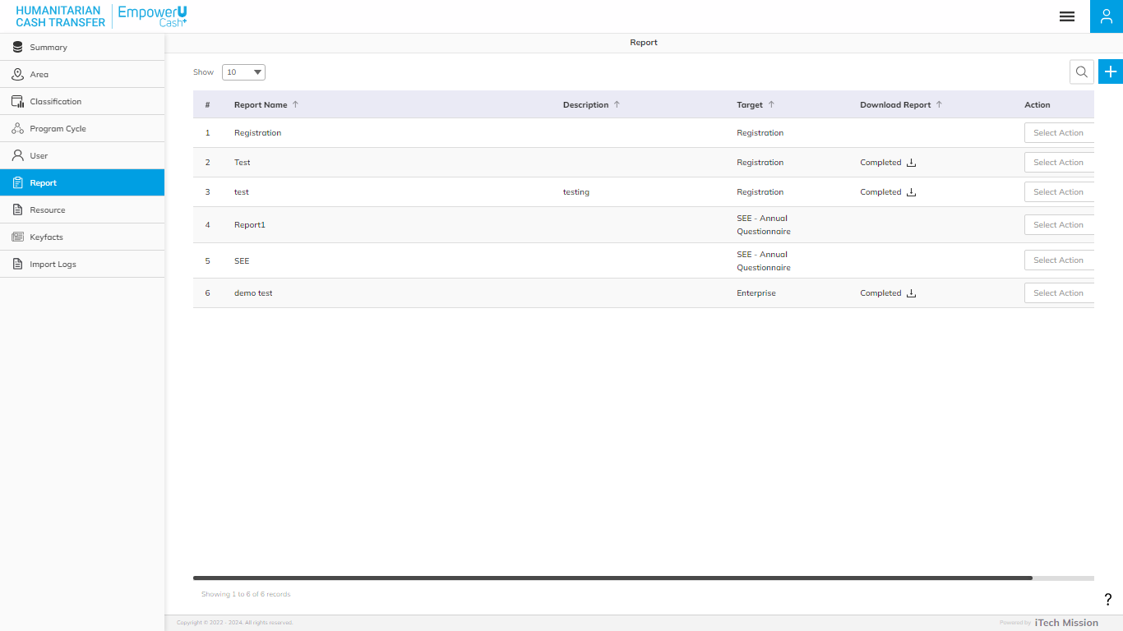**Step 42:** Click on the **Generate Report** option available under **Admin** to access this sub-module. You have the option to edit, delete, and run the existing reports from the list (see below figure).

#### 2.2.2.1 GENERATE REPORT

**Step 20:** Click the **Plus** button available on the right side of the page to generate a new **Report** **(**see figure below). 

The Add **Report** form is divided into sections namely – **Setup**, **Query**, **Calculate**, **Layout**, **Father Information,** and **Address Information**.

**Step 44:** Enter the following information to add a new **Live Birth** record –

|  |  |  |  |  |
| --- | --- | --- | --- | --- |
| **Field** | **Type** | **Import Type** | **Mandatory** | **Associated Classification** |
| **Report Name** |  |  |  |  |
| **Description** |  |  |  |  |
| **Dataset Type** |  | (Primary/Secondary) |  |  |
| **SM Unit** |  |  |  |  |
| **Topic and Subtopic** |  | **(if primary is selected)** |  |  |
| **Files** |  | (if primary is selected) |  |  |
| **Data Category** |  | **(if secondary is selected)** |  |  |
| **Dataset** |  | if secondary is selected) |  |  |
| **Column Names** |  |  |  |  |

**QUERY**

|  |  |  |  |  |
| --- | --- | --- | --- | --- |
| **Filter Name** |  |  |  |  |
| **Column** |  |  |  |  |
| **Level** |  | Associated |  |  |
| **Operator** |  |  |  |  |
| **Value** |  |  |  |  |

**CALCULATE**

|  |  |  |  |  |
| --- | --- | --- | --- | --- |
| **Column** |  |  |  |  |
| **Formula** |  | selecting column from the left column. |  |  |
| **Validate** |  |  |  |  |
| **Decimal Place** |  |  |  |  |

**Conditional Column**

|  |  |  |  |  |
| --- | --- | --- | --- | --- |
| **New Column** |  |  |  |  |
| **Column** |  |  |  |  |
| **Operator** |  |  |  |  |
| **Value** |  |  |  |  |
| **Label** |  |  |  |  |

**Layout**

|  |  |  |  |  |
| --- | --- | --- | --- | --- |
| **Title** |  |  |  |  |
| **Subtitle** |  |  |  |  |
| * Drag and drop **Rows** and **Columns** from the **Rows and Columns** section to **Columns, Rows,** and **Value**. |  |  |  |  |

Click on the **Add** button to save.

**Step 5:** Select the **Edit** option available in the action dropdown to edit the details of the selected element. Edit the required detail and click on the update button to save and confirm.

**Step 6:** Selectthe **Delete** option available in the action dropdown to delete the selected element. A confirmation popup will appear, click **Yes** to confirm the deletion of the selected element.

**Step 51:** Click to selectthe **Execute** option available in the action dropdown to run the report for a particular date range and get the download link of the report. The Data of the report can also be downloaded by clicking the **Download data** checkbox while execution.

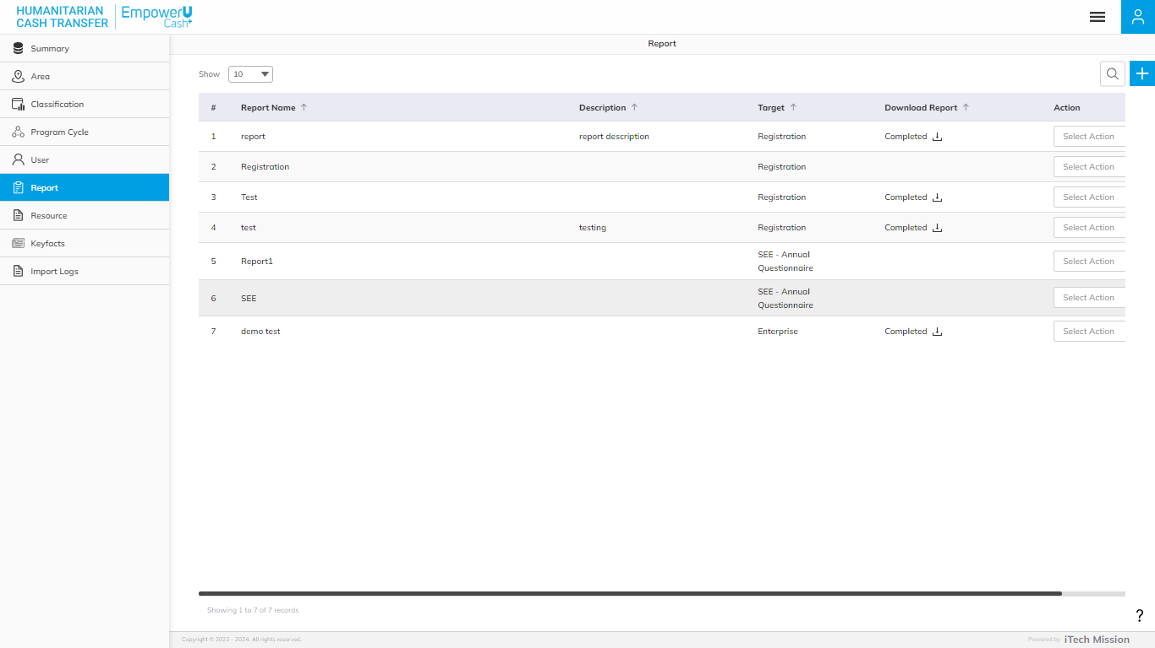**Step 52: Download** the report and data if checked **Download Data** checkbox by clicking on the download icon.

### **7.7 RESOURCE**

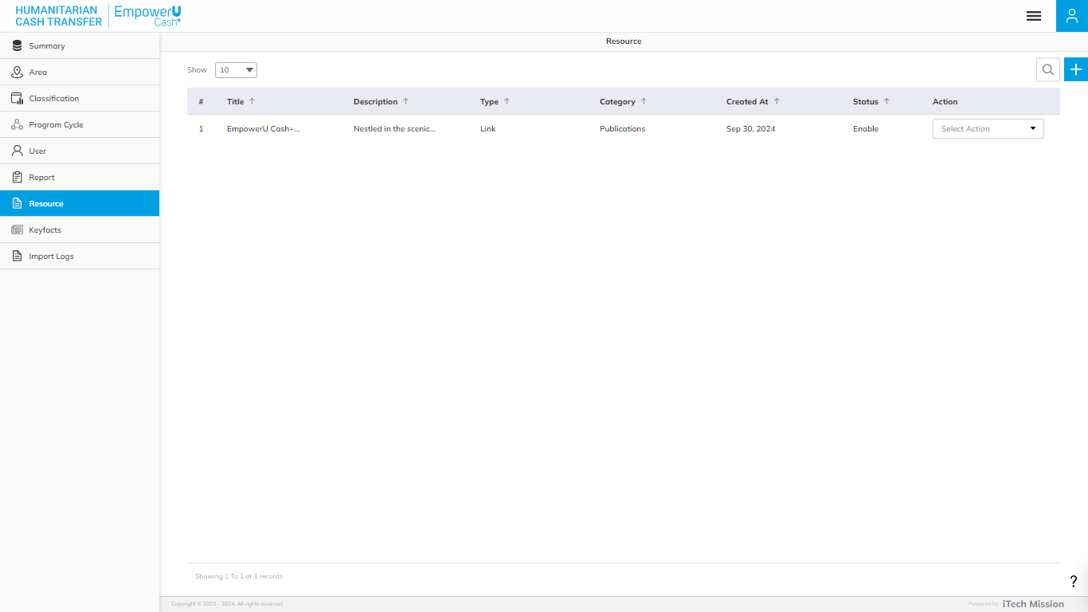Click on the **Resource** module option in the left navigation panel. This module allows you to manage the **Resource** master list. You will have options to add new resources, view the list of existing resources, search resources from the list, and edit existing resources from the list (see figure below).

#### **ADD RESOURCE**

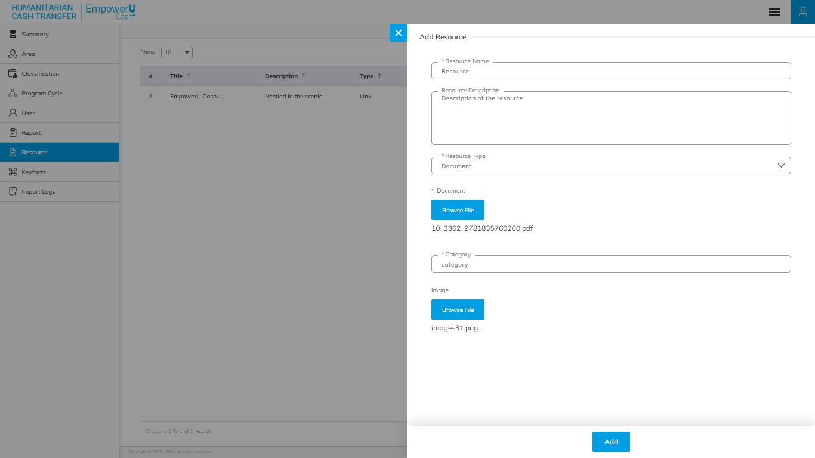Click on the **Plus** button that is available on the right side of the page to Add a new resource (see figure below).

Enter the following details to create a new **Resource**:

|  |  |  |  |  |
| --- | --- | --- | --- | --- |
| **Field** | **Type** | **Import Type** | **Mandatory** | **Associated Classification** |
| **Resource Name** | Text |  | Yes |  |
| **Resource Description** | Text |  | Yes |  |
| **Resource Type** | List | Single Choice | Yes | static |
| **Document** | Upload | (supported type - .docx, .pdf,.csv) | Yes |  |
| **Insert URL** | Test |  | Yes |  |
| **Category** | Text |  | Yes |  |
| **Image** | Upload | (supported type - .jpeg and .png) | No |  |

Click on the **Add** button to save and confirm. You can now view the new **User** added to thelist.

Click the **Search** button and specify the name to view entries.

Selectthe **View** option available in the action dropdown to view the details of the selected element.

Select the **Edit** option available in the action dropdown to edit the details of the selected element. Edit the required detail and click on the update button to save and confirm.

Selectthe **Delete** option available in the action dropdown to delete the selected element. A confirmation popup will appear, click **Yes** to confirm the deletion of the selected element.

Select the **Enable/Disable** option available in the action dropdown to show or hide the specific element. The hidden element will not be shown in the list of selected Area types overall in the application.

### **7.8 KEYFACTS**

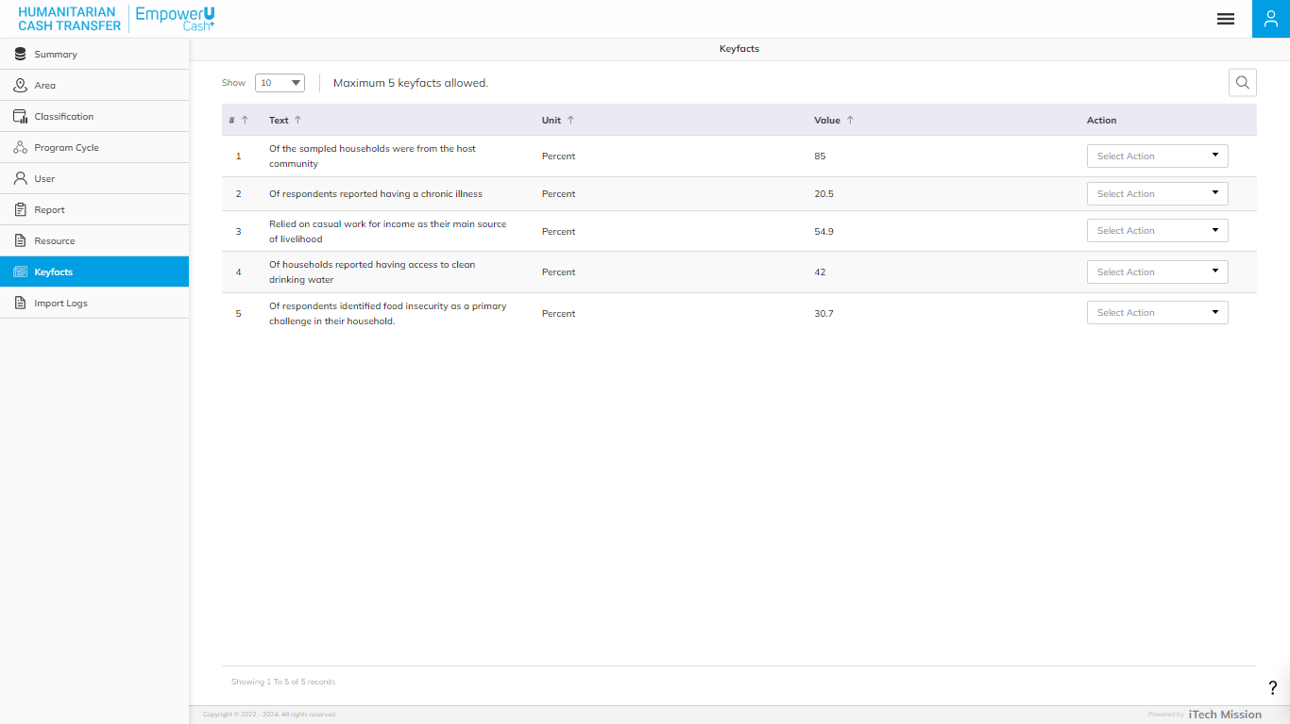Click on the **Keyfacts** module in the left navigation panel. This module allows you to manage the master list of **Keyfacts** You will have options to add new keyfact, view the list of keyfact, sort the list, search keyfact from the list, and edit a keyfact.

#### **ADD KEYFACTS**

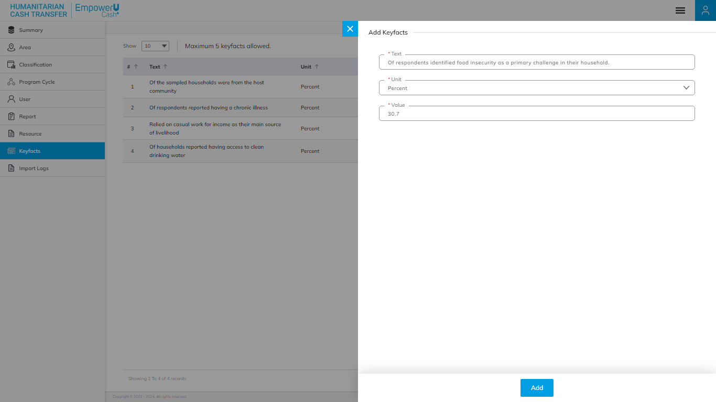**Click on the **Plus** button available on the right side of the page to add a new classification for the selected **Keyfacts** type. (see below figure)

Enter the following details to create a new **Keyfacts**:

|  |  |  |  |  |
| --- | --- | --- | --- | --- |
| **Field** | **Type** | **Import Type** | **Mandatory** | **Associated Classification** |
| **Text** | Text |  | Yes |  |
| **Unit** | List | Single Choice | Yes | static |
| **Value** | Text |  | Yes |  |

*Maximum 5 keyfacts allowed*

Click on the **Add** button to save and confirm. You can now view the new **User** added to thelist.

Click the **Search** button and specify the name to view entries.

Selectthe **View** option available in the action dropdown to view the details of the selected element.

Select the **Edit** option available in the action dropdown to edit the details of the selected element. Edit the required detail and click on the update button to save and confirm.

Selectthe **Delete** option available in the action dropdown to delete the selected element. A confirmation popup will appear, click **Yes** to confirm the deletion of the selected element.

Select the **Enable/Disable** option available in the action dropdown to show or hide the specific element. The hidden element will not be shown in the list of selected Area types overall in the application.

### **7.9 IMPORT LOG**

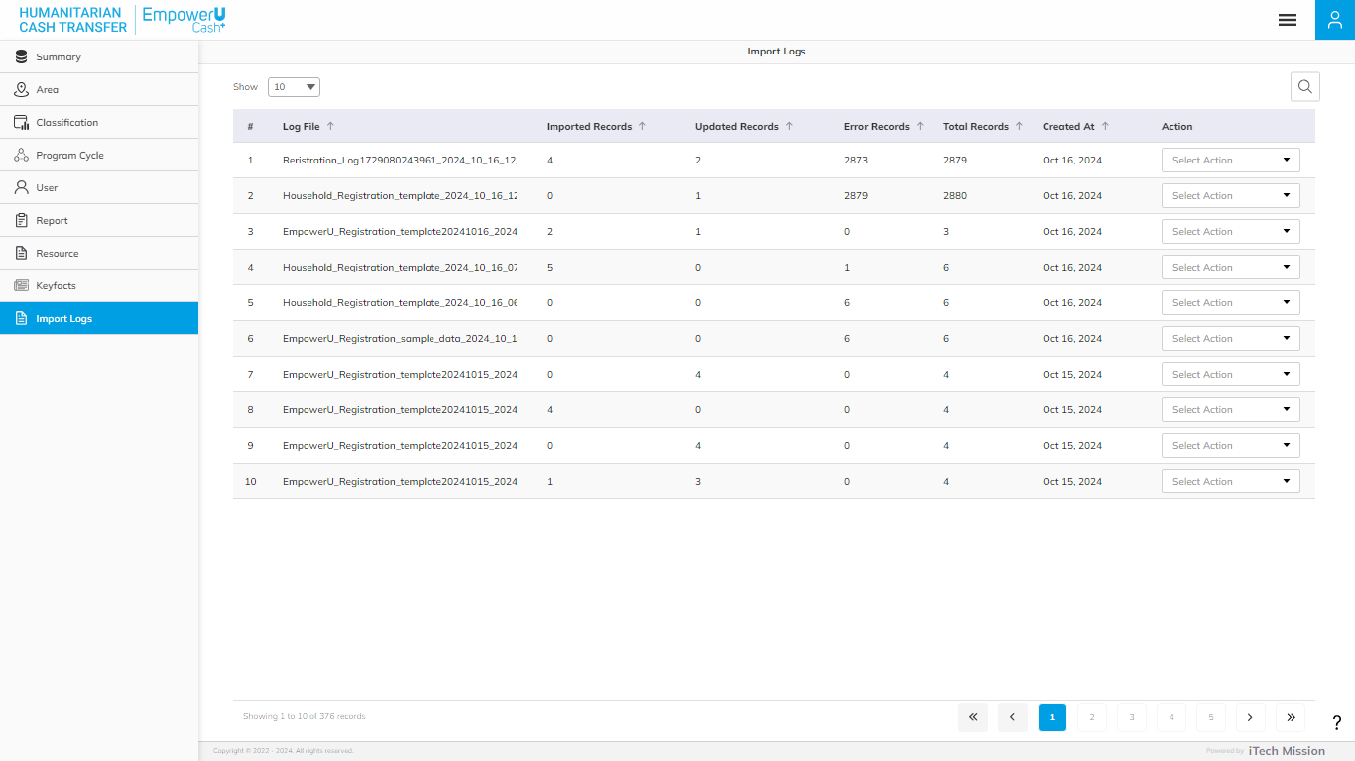Click on the **Import** **Log** module option in the left navigation panel. This module allows you to manage the Data **Import Log** master list. You will have the option to view the list of existing logs, download and view log reports, and delete selected records (see figure below).

A log will be generated whenever any data template is imported into the database. A list of import logs is shown on this page where each import log is shown as a row. You can see the file name of each import log along with the log summary that includes: the count of records imported, the count of records updated, the count of error records, the total records available in the import file, and the date & time of the import. You also have the option to download the log file to view the reason for error records or delete the log file. The log file will be downloaded in CSV format.

-- End of the document --